**Perform fact-finding and produce data analysis based on the findings gained. (P1.1)**

1. **Fact finding and Data analysis**
2. **Fact Finding technique**
   1. **Interview**

Interview is a method used to collect data and information from face-to-face interviews. The aim of interview is to find, verify, clarify facts, motivate end-users involved, identify requirements and gather ideas and opinions between interviewers and interviewee. In order to make the interview session success, the interviewer must appropriately prepare for the question that need to be asked for the proposed system. Usually, the information collected from interview session is quite accurate and reliable as the interviewer can cross check the doubts and the misunderstanding. Interviewer and interviewee also can discuss about the future problems. (Shah, 2019)

From the interview session that has been held on 17th June 2018, there are many information that has been collected in order to develop the proposed system which is e-Donation Application. The interview has been held within 17 minutes with Chairman of Koperasi KPM Beranang which is En Zakaria bin Rosman. There were about 7 questions for the interview and all the question has been answered. The interview session was made to get all the requirements for the e-Donation Application. The interview outline and report is attached in this report.

* 1. **Observation**

Observation is one of the fact-finding techniques that has been implemented. Observation is a technique to collect information by observing the business process and current system. By using this technique, the developers have the chance to experience the current system themselves, not just relying on the words of the users. (System Analyst's blog, 2019)

Based on the observation that has been conducted on 17 June 2019 at Encik Zakaria bin Rosman’s space in Science Quantitative Department, there is a file which Encik Zakaria keep in his space. The file only keeps the important letter of the donation application. There is no report that can summarize the yearly donation that has been given to the applicant.

1. **Evidence of Fact-Finding**

|  |  |
| --- | --- |
| **Interview Outline** | |
| **Interviewee: En Zakaria** | **Interviewer: Athirah bt Ahmad Fauzi** |
| **Location: KPM Beranang** | **Date :17/6/2019** |
| **Objectives: To gather requirements and information for e-Donation Application** | **Reminders: - none** |
| **Agenda:** | **Approximate Time:** |
| Introduction | **1 min** |
| Overview of Interview | **1 min** |
| Question 1 | **2 min** |
| Question 2 | **1 min** |
| Question 3 | **1 min** |
| Question 4 | **2 min** |
| Question 5 | **2 min** |
| Question 6 | **2 min** |
| Question 7 | **2 min** |
| Summary of Major Points | **1 min** |
| Question From Interviewee | **1 min** |
| Closing | **1 min** |
| **General Observations: Encik Zakaria gave a good respond within the time.** | |
| **Unresolved Issues: None** | |

* 1. **Interview Outline**
  2. **Interview Report**

|  |  |
| --- | --- |
| **Interviewer** | **Interviewee** |
| Question 1:  What is the current system used to apply and track the donation for the college’s activities? | Our current system right now is manual which is using filing system. The organization/clubs that want to apply for the donation have to write a formal letter and send it to me. While, me as the person in charge who manage the donation application have to file in all the application in one file. |
| Question 2:  What are some of the problems you experience using the current system? | The problem of our current system is we cannot keep track the amount of the donation that has been given to the Organization/Department. |
| Question 3:  How many staff involved in manage the current system? | Me and few others member of Koperasi KPM Beranang are people involve in order to manage the donation that has been applied by the clubs or organization. |
| Question 4:  What kinds of data do you work with? | We manage the data on Name of Program/Events, Date of the Program/Events, Person in Charge, Department/Organization, Amount of Student Involve in the Program, Amount of Donation and Approved Amount of Donation. |
| Question 5:  If we proposed the new system, what are the requirements needed? I mean, the functionality needs to be provided in the system | We need the system that is able to apply for the donation. The system also is able to manage the application of the donation. In the same time, the system also can provide me with the appropriate report which is can summarize the application of the donation. |
| Question 6:  What kind of report would like the system to be able to generate? | Total Amount of Donation Applied by Department/Organization. |
| Question 7:  Do you want the system to be stand-alone or it can be used in college area or even online? | I would like the system to be online system which can be access by the students and staff in our college. |

* 1. 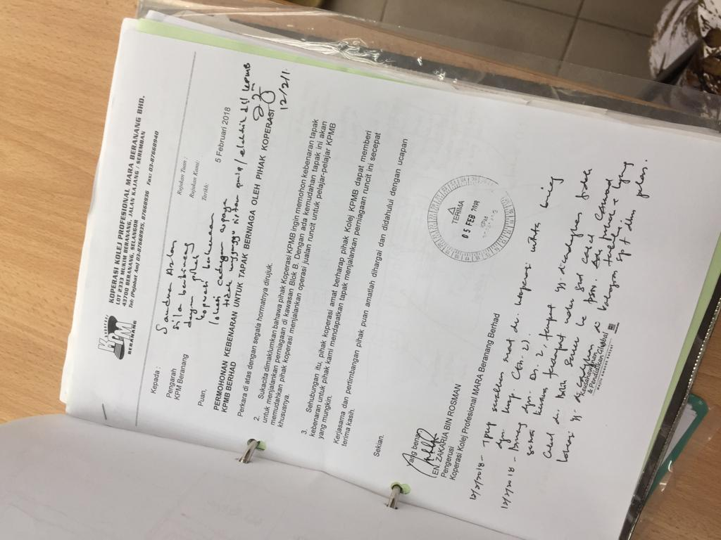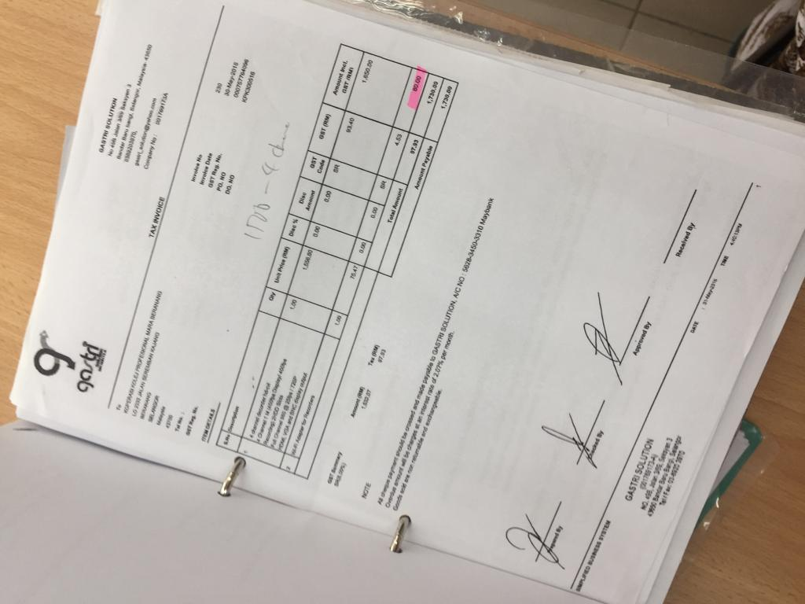**Observation**

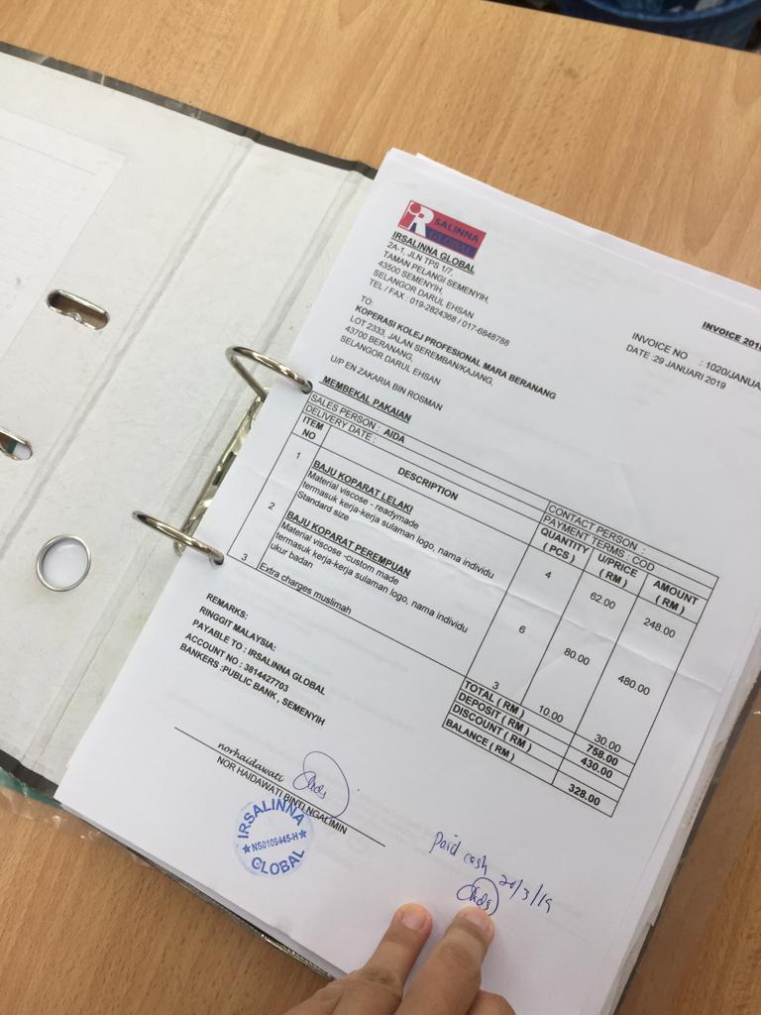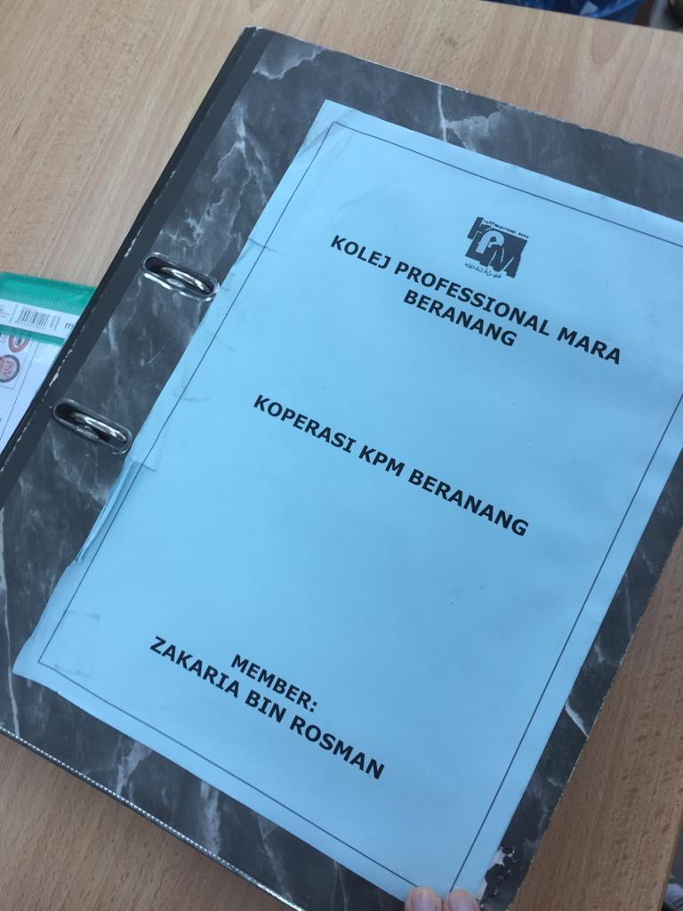**Figure 1: Pictures of Document that involved in the process**

1. **Fact-finding Analysis**
   1. **Current Situation**

The current system that has been used by the Koperasi KPM Beranang is manual which is by using filing system. The Organization/Department that want to apply for the donation have to make formal letter and give it to Encik Zakaria for the approval whether the Organization/Department eligible for the donation or not. While, Encik Zakaria bin Rosman, chairman of Koperasi KPM Beranang is the person who manage the donation application which he has to file in all the application in one file.

There is a problem regarding to the current system which is he cannot keep track the amount of the donation that has been given to the same Organization/Department. The current system also lacks of flexibility because the system only can be managed by one person at a time as it used manual filing. Other than that, the staff or students who want to apply for the donation also must write a formal letter and give to chairman of Koperasi KPM Beranang which not flexible.

* 1. **Recommendation**

The name of propose system is e-Donation Application. The system will be online system which can be accessed by the staff and students of KPM Beranang. The system will be implemented with a form which must be filled in by the staff or student in order to apply for the donation. The important data that will be implemented in the form are Name of Program/Events, Date of the Program/Events, Person in Charge, Staff of Koperasi KPM Beranang, Department/Organization, Amount of Student Involve in the Program, Amount of Donation, attachment of notice letter, Email address and Telephone No of the person in charge.

Furthermore, the system also can be signup and logged in by member of Koperasi KPM Beranang. The members can manage the donation by giving approval to the application. The system also can help the members to keep track the amount of the donation that has been given to the Organization/Department. The system also will be able to generate report that can summarize the donation application and summarize total amount of donation that has been given to the organization or department.

* 1. **Significance of Recommendation.**

The system will give positive impact toward the member of Koperasi KPM Beranang and staff and student of KPM Beranang. The system will ease the staff and students of KPM Beranang in order to apply for the donation because the system can be accessed through online. The system also can ease the member of Koperasi KPM Beranang to manage the donation by giving approval to the donation application. They also can easily track the donation that has been approved and given to the Organization/Department. Since the current system need their user to use a lot of paper, the proposed system will help in reducing the paper waste and reducing space to keep all the document. The proposed system will be fully computerized including the application form and the yearly and monthly report.

**Discuss at least three problem related with conducting the selected fact findings techniques and justify how to overcome these problems briefly. (M1.2)**

1. **Interview**

There are two fact-finding techniques that has been conducted which are interview and observation. There are few problems related to the both of the fact-finding techniques.

One of the problems of interview is **unclear question**. Interview is one of the effective methods to gather all the important data in order to develop a system. But this method may can cause the interviewer to give unclear question to the interviewee which could not be understood. The interviewer may do not well prepare the question appropriately before the interview session which make the interviewee understand the question differently and transcribe interview in the different ways. For examples related to the development of e-Donation Application, if the developer does not prepare the question to be asked to the client which is Koperasi KPM Beranang, the developer may give unclear question which could not be understood easily such as what is the requirement specification for the system. This can cause the client give different answer to the question. So, in order to overcome this problem, the developer must **make some preparation before the interview**. The developer should well prepare all the related question for the proposed system. The question must be in simple language which could be understood by the interviewee. Other than that, the developer also should make some research on the correct question to asked to the interviewee. (Evalued.bcu.ac.uk, 2006)

The other problem related to interview method is **time consuming**. Interview techniques could be very time consuming. This is because the developer must firstly set up time for the interview session with the interviewee. This could be biggest problem in conducting this technique because the interviewee may busy and does not have time for the interview session. Other than that, the interviewer also must set up the place to conduct the interview. the interview must look for appropriate place to run the interview session. Interview also could be time consuming as the interviewer must ask the question one by one and must wait the interviewee to answer all the question correctly. So, in order to overcome this problem, the developer and the client must **make discussion on the time and place to conduct the interview**. The developer and client should discuss the appropriate time and place to run the interview session. They have to find the suitable time which both of the interviewer and interviewee do not busy and have free time which they can spend their time to questioning and answering for the proposed system. For example, related to the proposed system e-Donation Application, the developer and the client had some discussion on the time and place to conduct the interview. The time and place chosen is very suitable as both of the interviewer and interviewee had free time during the planned time. So, the interview is conducted in proper way without rushing and all the question was answered. (Evalued.bcu.ac.uk, 2006)

The other problem of interview technique is the **interviewee may not willing to provide the information**. Interview is the most useful and effective technique to get all the required information to develop the system. But sometime, it could be so hard to get the required information because the interviewee may not willing to give the answer and information for the asked question. It is because the information may be so confidential which could not give it to the other party. For example, related to the proposed system e-Donation Application, there are few questions that the interviewee was not willing to answer as it is related to their confidential. So, in order to overcome this problem, before the interview start, the interviewer must **advise to the interviewee that all of their confidential information will be respected**. The interviewer must convince the interviewee that all the information they get from the interview session will be respected and will be kept save among them. So, from this, the interviewee may willing to answer the question and provide the required information even though the information is confidential for them. (Evalued.bcu.ac.uk, 2006)

1. **Observation**

The other fact-finding technique that has been conducted is observation. There are few problems related to observation technique. One of the problems is **hard to analyse data**. Observation is a technique that can give the developer additional perspective to the better understanding the process of the system. But observation may could make the data hard to analyse. It is because the developer has to observe and learn the way of the client on how they perform the activities of the current system. So, from that the developer has to analyse the information to be included in the proposed system. But it could be so hard to analyse as the observation does not straightforward which is it not give any data to the developer. The developer has to observe and analyse it by themselves. For example, related to the proposed system e-Donation Application, the developer has conducted observation in which they have to observe the works done by the client. Then, the developer took the picture of the work done and has to analyse the data from the picture. But, the developer found out that the data is hard to be analysed. So, in order to overcome this problem, the developer must find another alternative such as **conduct another fact finding**. If observation make data is hard to analyse, the developer should conduct another fact finding in which it can make the data is easy to be analysed. Another fact-finding that can be done is questionnaire. Questionnaire is very hard to be conduct because it requires a lot of candidate to answer all the questionnaire. But from the questionnaire, the developer can easily analyse the data because all the data required for the proposed system is all in the questionnaire. (Elks, 2014)

The other problems related to the observation is **interruptions**. When conducting observation, interruption may be occurred. It is because the work observed may be conducted in the place where other people are in there too. The people may interrupt the process of work that the developer observed and this not convenient because it can disturb the developer to observe the activities. From this the developer will not get the required information for the proposed system. For example, related to the e-Donation Application, the observation has been conducted in the client office in Science Quantitative Department in which there are other people who interrupt the work process of the client. So, in order to overcome this problem, the developer **should provide notice to the client**. The developer should provide notice to the client that the observation will be conducted in that time. Then the client must inform to the other people in the office to not interrupt during the observation process to ensure that the work process can be done smoothly. (Elks, 2014)

The last problem related to the observation is **the work observed may not representative normal condition**. During the observation is conducted, the work observed may not representative normal condition in which the person who in charge for the job may doing different activities from the activities they do before. Also, the activities may be done by different person from the real person who actually conduct the activities. Thus, from this the developer may get different data from the observation compare the normal activities. So, the developer cannot analyse the real data. For example, related to the proposed system e-Donation Application, the observation has been done at not right time in which the client is busy with their own task and not in the representative normal condition. So, in order to overcome this problem, the developer **should discuss with the client the time to conduct the observation.** In order to conduct the observation in which the work observed is representative the normal condition, the developer must discuss with the client to choose the right time in which the real person can run the activities. So that, the developer can get the real data to be analysed. (Elks, 2014)

**Show that the identified problems in the current situation have been solved. Produce suitable print screen and justification. (D3.4)**

The identified problem of the current situation for Koperasi KPM Beranang is the manual system is **unable to keep track the donation that has been given to the same Organization/Department**. The current system is very unpractical in which the member of the Koperasi KPM Beranang cannot keep track the donation that has been given to the same Organization/Department because they use manual system which the does not provide any report.

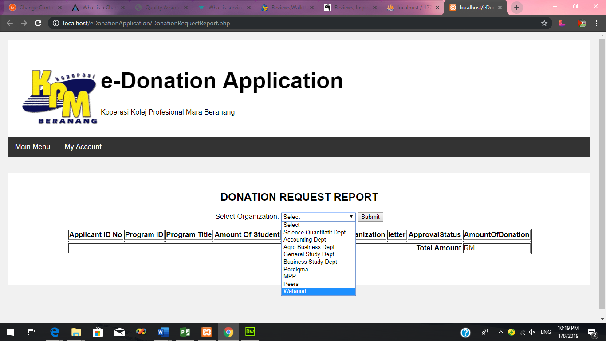 So, this problem has been identified and solved where the developed system, e-Donation Application has the report function which member can search the Organization/Department and display the report of the donation that been given to the selected Organization/Department. So, the members of Koperasi KPM Beranang will be able to keep track the donation that has been given to the same Organization/Department. The evidence of the functionality in the system is as below.

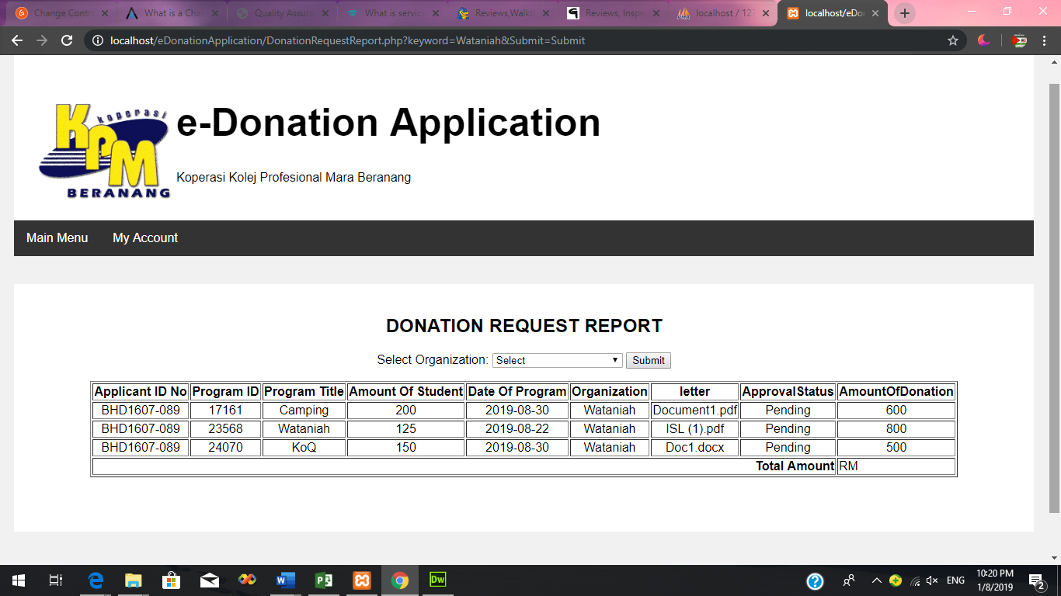**Figure 2: Select Organization/Department**

**Figure 3: Report by Organization/Department**

The other identified problem of the current system is the system **only can be managed by one member of Koperasi KPM Beranang**. The manual system only can be managed by En Zakaria and cannot be managed by other members. It is because the manual system used paper and filing which only can be managed by one person.

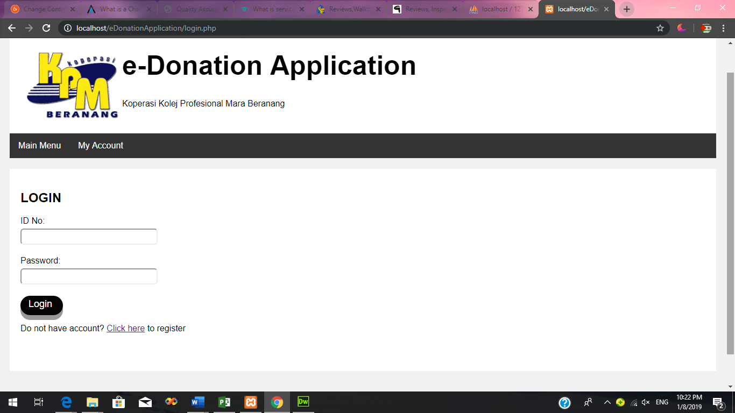 So, the problem has been solved in which the developed system has sign up and log in form which can be access by members of Koperasi KPM Beranang in order to manage the donation request. The system has been developed where all the members can sign up and log in to the system to manage and maintain the donation request. The members can log in to the system and the system will display the main menu which has the button to maintain the donation request.

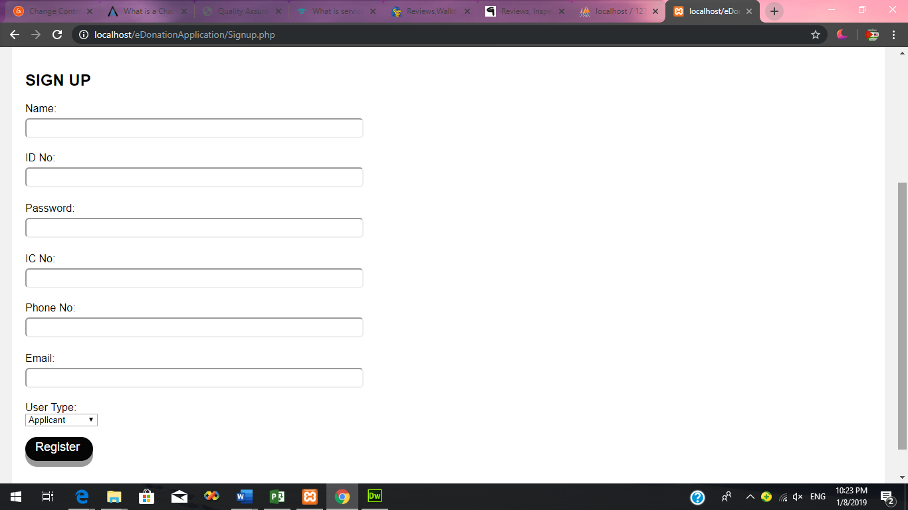**Figure 4: Login Form**

**Figure 5: Sign up Form**

The last problem that has been identified from the current system is the **applicant that want to apply for the donation must write the formal letter and give the letter to one of members of Koperasi KPM Beranang** and this is not flexible. Then the applicants have to meet again the members of Koperasi KPMB for the confirmation.

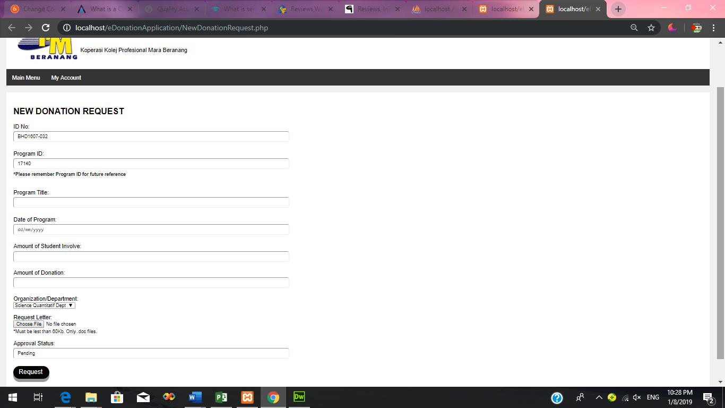 This problem has been solved in the developed system where the system will be implemented with the donation request form and the system also will be online-based system in which the applicant must sign up and log in to the system. The applicant can request for the donation through the system by fill in the request form that has been implemented in the system. The applicant also can check the approval status of the donation through the system.

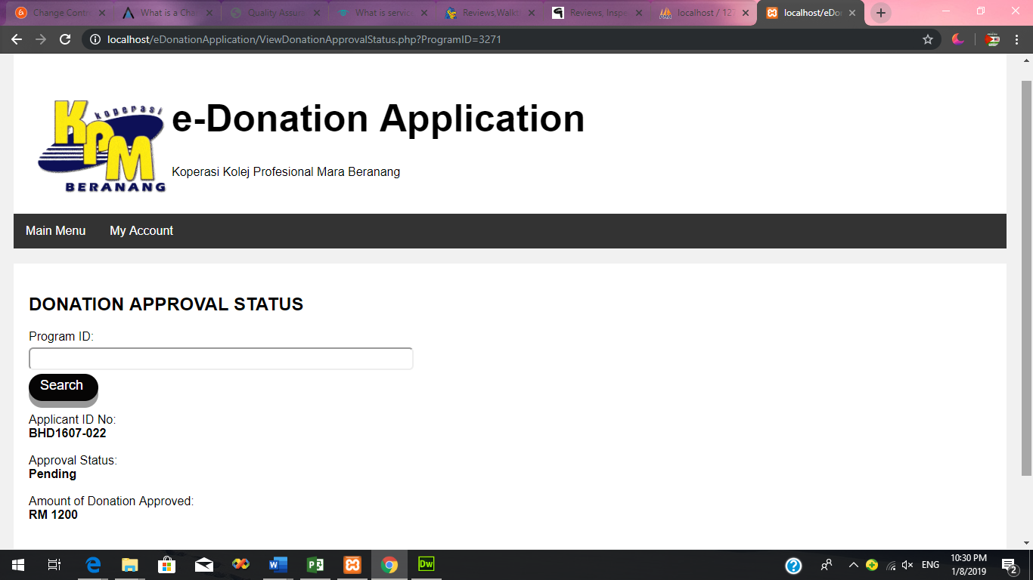**Figure 6: Donation Request Form**

**Figure 7: View Donation Request Approval Status**

**Conduct a feasibility assessment that contributes to the process of project selection. (P1.2)**

1. **Technical Feasibility**

Technical feasibility is the technical resources that is needed to develop, install, purchase or operate the system (Shelly and J. Rosenblatt, 2019). The proposed system which is e-Donation Application will be develop by using **Adobe Dreamweaver CS6**. So, there are few PC specification that need to be considered by the developer in order to install the software.

Below is the table of the developer’s PC specification and minimum requirement specification of Adobe Dreamweaver CS6.

|  |  |  |
| --- | --- | --- |
| Items | PC Specification Developer | Minimum Requirement |
| Processor | Intel® Core™ i5-7200U (2.5 GHz, up to 3.1 GHz, 3 MB cache, 2 cores) | Intel® Pentium® 4 or AMD Athlon® 64 processor |
| Memory | 4 GB DDR4-2133 SDRAM (1 x 4 GB) | 512 MB of RAM |
| Hard disk | 1 TB 5400 rpm SATA (778 GB free of 1 TB) | 1 GB of available hard-disk space for installation; additional free space required during installation |
| Graphic Display | 1366 x 768 with AMD Radeon™ R5 M430 Graphics (2 GB DDR3 dedicated) | 1280 x 800 display with 16-bit graphics adapter |

Based on the table above, the minimum requirement specification for processor to install Adobe Dreamweaver CS6 is Intel® Pentium® 4 or AMD Athlon® 64 processor. The developer’s PC specification for processor is Intel® Core™ i5-7200U (2.5 GHz, up to 3.1 GHz, 3 MB cache, 2 cores). So, the developer’s PC is suitable to install the software.

Then, the minimum requirement for memory (RAM) to install Adobe Dreamweaver CS6 is 512 MB. While, the developer’s PC specification is 4GB DDR4-2133 SDRAM (1 x 4 GB) which very suitable and adequate to install the software in order to develop the system

Next, the minimum requirement for hard disk in order to install the software is at least the PC has 1 GB of available hard-disk space for installation and additional free space during the installation. Meanwhile, the developer PC specification for hard disk is 1 TB 5400 rpm SATA which now it has 778 GB free of 1 TB which is very adequate to install Adobe Dreamweaver CS6.

Then, the minimum requirement for graphic display in order to install Adobe Dreamweaver CS6 is 1280 x 800 display with 16-bit graphics adapter. While, the developer’s PC specification for graphic display is 1366 x 768 with AMD Radeon™ R5 M430 Graphics (2 GB DDR3 dedicated) which is very suitable and adequate to install the software.

In conclusion in term of technical expertise, there are sufficient resources to manage the development of e-Donation Application since there are enough staff and team member that involved in the project which is project manager, system analyst, system designer, programmer and system tester.

1. **Operational Feasibility**

Operational feasibility is referred to the measure of solving problems with the help of the proposed system. It is also used to determine and identify the problem in system and how the proposed system can help to solve the problem (Evirtualservices.com, 2019). So, there are few problems that has been identified regarding the current system of donation application that has been used by Koperasi KPM Beranang.

Below is the table shows the problem of the current system, the expected functionality of the proposed system and how the proposed system solve the problem.

|  |  |  |
| --- | --- | --- |
| **Problems** | **Functionality (Expected)** | **How it solves the problem** |
| The current manual system is unable to keep track the donation that has been given to the same Organization/  Department | Generate report | The proposed system can help the members of Koperasi KPM Beranang to keep track the donation that has been given to the same Organization/  Department by generating report of selected Organization/ Department from the system database and display the total amount of the donation. |
| The current system only can be managed by one person of member of Koperasi KPM Beranang | Sign up and log in by the members | The proposed system will have sign up and log in form which can be access by members of Koperasi KPM Beranang in order to manage the donation |
| The applicant that want to apply for the donation must write the formal letter and give to one of members of Koperasi KPM Beranang which is not flexible. | Sign up and log in by the applicant and online donation request form | The proposed system will be online-based system which the applicant must sign up and log in to the system. The applicant can fill in the important data in the request form that has been implemented in the system in order to apply for the donation. |

1. **Schedule Feasibility**

Schedule Feasibility is described as the likelihood that a project will be finished by a planned due date within its scheduled time boundaries. If a project has a high likelihood of being finished on time, the feasibility of its timetable is reviewed as high (Taskmanagementguide.com, n.d.). Below is the schedule in order to develop e-Donation Application.

Project Name: e-Donation Application

Start Date: 17/06/2019

End Date: 29/07/2019

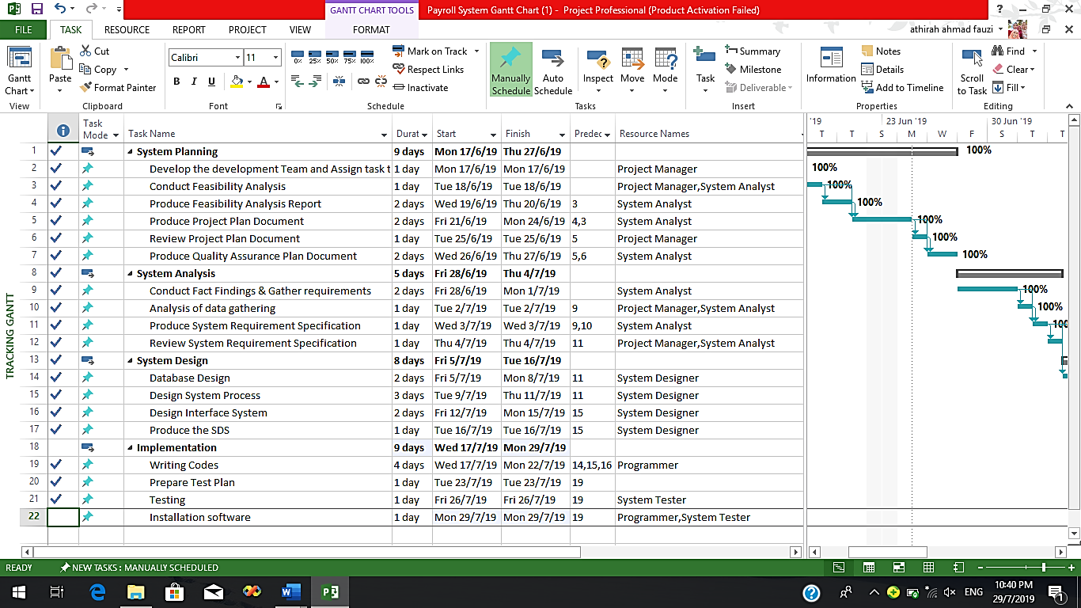Duration: 3 Months

**Figure 8: Schedule for the development of e-Donation Application**

Based on the schedule above, the first stage of development of e-Donation Application is **System Planning**. This stage will be conducted in 9 days which from 17th June 2019 to 27th June 2019. In this stage, there are few task breakdowns that will be conducted. The tasks are develop the development team and assign task to the team, conduct feasibility analysis, produce feasibility analysis report, produce project plan document and produce quality assurance plan document. The team member that will be involve in this stage are Project Manager and System Analyst.

The next stage that will be conducted in this project is **System Analysis**. This stage will be conducted in 5 days from 28th June 2019 until 4th July 2019. The that are involved in this stage are conduct fact findings & gather requirements, analysis of data gathering, produce system requirement specification and review system requirement specification. Project manage and system analyst also will involve in this stage.

The other stage that will be conducted to development e-Donation Application is **System Design**. This stage will be conducted in 8 days which is from 5th July 2019 until 16th July 2019. The task breakdown that will be conducted in this stage are database design, design system process, design interface of the system and produce the system design specification. The team member that will be involved in this stage is only system designer.

The last stage that will be conducted is **implementation**. The implementation of e-Donation Application will be conducted in 8 days which is from 17th July 2019 until 29th July 2019. The task that will be conducted in this stage are writing codes, prepare test plan, testing and installation software. The team member that will be involved in this stage are programmer and tester.

As a conclusion, based on the schedule above, the task breakdown that has been divided is compatible with the analysed date.

1. **Economic Feasibility**

Economic feasibility is to measure of the cost-effectiveness of a project or solution (Webcache.googleusercontent.com, n.d.). Below is the economic feasibility that has been identified for e-Donation Application.

1. Benefits
   * 1. Tangible Benefits

|  |  |
| --- | --- |
| Tangible Benefits (year 1-2) | |
| Error reduction | RM2,500 |
| Increase speed of activity | RM3,700 |
| Cost avoidance | RM3,500 |
| Reduction of salary | RM5,000 |
| Total Tangible benefits | RM14,700 |

Year 1 – RM7,350

Year 2 – RM7,350

* + 1. Intangible Benefits
       1. **Improve the work process**

By implementing e-Donation Application in KPM Beranang, it can lead to time reduction for the both of parties which are the member of Koperasi KPM Beranang and the applicant of the donation. It is because the system is online-based system which can be accessed anywhere and anytime by both of the parties. The system will be implemented with donation request form where the applicant just fill in the form to make donation request instead writing letter which requires a lot of time. The members of Koperasi KPM Beranang also can easily approve the donation by clicking on the approve button which will save more time.

* + - 1. **Increase organizational responsibility.**

By implementing e-Donation Application for Koperasi KPM Beranang, it can increase the organizational responsibility. It is because the system can be access by all the members of Koperasi KPM Beranang. The current system only can be managed by one person as it used manual filing but by implementing e-Donation Application, the member can sign up and log in to the system and can easily manage the donation application. So, it can increase the organizational responsibility and performance.

* + - 1. **Timely reliable information**

By implementing e-Donation Application for Koperasi KPM Beranang, it can help for fast and easy data retrieval because the system can save all the important data regarding the donation application in the database. Instead of finding the data in physical file, the member of Koperasi KPM Beranang can easily retrieve the previous data from the database in the system without worrying of the data loses.

1. Cost
   * 1. On Time Cost

|  |  |
| --- | --- |
| Details | Cost |
| Hardware cost | RM1,900 |
| New software cost | RM1,500 |
| Development cost | RM8000 |
| Total | RM11,400 |

* + 1. Recurring Cost

|  |  |
| --- | --- |
| Details | Cost (Year 1-2) |
| Utilities bill | RM400 |
| Staff salary | RM2,000 |
| System Maintenance (Monthly) | RM1,500 |
| Total | RM3,900 |

Year 1 – RM1,950

Year 2 – RM1,950

1. Net Present Value (NPV)

Below is the NPV for e-Donation Application. The start-up cost is RM11,400 and the project required to be developed for 2 years and the discount rate is 10%.

|  |  |  |  |
| --- | --- | --- | --- |
| Year | Cash Flow | Discount factor | Present Value |
| 0 | -(11,400) | 1 | -(11,400) |
| 1 | 5,400 | 0.9091 | 4,909.14 |
| 2 | 5,400 | 0.8264 | 4,462.56 |
| Net Profit: | 600 | NPV: | 2,028.30 |

Below is the NPV for Payroll System. The start-up cost is RM6,800 and the project required to be developed for 2 years and the discount rate is 6%.

|  |  |  |  |
| --- | --- | --- | --- |
| Year | Cash Flow | Discount factor | Present Value |
| 0 | -(10,200) | 1 | -(10,200) |
| 1 | 5,400 | 0.9434 | 5,094.36 |
| 2 | 5,400 | 0.8900 | 4,806.00 |
| Net Profit: | -600 | NPV: | -299.64 |

From the calculation, it shows that NPV for e-Donation Application is 2,028.30 which is a positive value. While, the NPV for Payroll system is -299.64 which is negative value. In conclusion, net profit for e-Donation Application is RM600 which can be achieved in 2 years and the project can be accepted for the development. While, for Payroll System, the net profit is -600 which cannot be achieved and the project cannot be accepted for the development.

**Justify in details the** **importance of conducting the feasibility assessment as a method** **to select the most significant project to be developed. (M2.4)**

Conducting feasibility assessment is the crucial step in the development of e-Donation Application. There are few importance of conducting the feasibility assessment as a method to select the most significant project to be developed.

One of the importance is **to** **provide valuable information for decision making**. Conducting feasibility assessment is an important method to assess potential that can help developer to get the answer to question and predict the likelihood of success or failure. In feasibility study, there are elements that need to be assess such as technical feasibility, operational feasibility, economic feasibility and schedule feasibility. All the element can help in changing, adapting and incorporating new products and ideas into business that are ways to remove some of the uncertainties, but without proper forethought and planning, those steps themselves can be highly uncertain. Conducting feasibility assessment can provide valuable information for decision making to select the most significant project to be developed. Based on the feasibility assessment that has been conducted, there are few elements that has been considered in order to select e-Donation Application. The elements that were considered is technical feasibility and economic feasibility. Based on both of the feasibility, e-Donation Application has been selected to be developed because it is the most efficient system to be developed compared to other system. For technical feasibility, in order to develop e-Donation Application, the developer does not have to buy another hardware since the developer PC specification has already met the minimum requirement for the software to develop e-Donation Application. Other than that, for economic feasibility that has been defined, e-Donation Application has been selected because it is the most valuable system compared to other system which is Payroll System. (Simplilearn.com, 2019)

The other importance of conducting the feasibility assessment as a method to select the most significant project to be developed is **it help in identifying potential problems to be solved.** Feasibility assessment has the element that can help in identify the problem of the current system and how the proposed system can help to solve the problem. The element is operational feasibility. Operational feasibility will identify the problems that need to be solved in current system and it also will analysed the functionality of the proposed system that can solves the current problem. Operational assessment can help in selecting e-Donation Application as the most significant project to be developed because the project has the potential problem that can be solved easily in given timeframe. E-Donation Application has three potential problems and the solution for all the problems has been analysed in the proposed system. It showed that the proposed system can be developed in the given time. So, feasibility assessment can be the method to select the most significant project to be developed is it help in identifying potential problems to be solved**.** (Simplilearn.com, 2019)

The last importance is it **can better help a business and a project manager deciding if the project will be profitable**. Feasibility assessment is the method to select the most significant project to be developed because it helps the project manager in analysing and defining the profit that they can gain from the project. There are schedule feasibility and economic feasibility that can help project manager to decide which is the most profitable project. The schedule feasibility is the way to define how much time the developer has in order to complete one project. While, the economic feasibility is method to analyse which project will give profit to the developer in the period of planned schedule. For example based on the feasibility assessment that has been conducted, e-Donation Application has been selected because it can give high profit to the develop compared to Payroll System. From the calculation in economic feasibility, it showed that e-Donation Application is selected to be developed as will give net profit which is RM600 that can be achieved in 2 years. While for Payroll System, this project could not be accepted because the net profit is -RM600. So, feasibility assessment is a great method to decide if the project will be profitable to be developed. (RAVI.R, 2016)

**System Requirement Specifications**

1. **Introduction**
   1. **Purpose**

The purpose of this system requirement specification is to details and describes the features and behaviour of the e-Donation Application. This document contains all the information needed to develop e-Donation Application such as intended audience, limitation of the system, constraint to develop the system, functional and non-functional requirement of the system and the interface requirement of the system.

* 1. **Intended Audience**

1. Project Manager: As a guideline to develop e-Donation Application and track the progress of the develop.
2. System Analyst: As a guideline to evaluate the project need and identify the appropriate solution for the development of e-Donation Application.
3. System Designer: As a guideline to design the flow and interface for e-Donation Application.
4. Programmer: As a guideline to refer the requirement for the system in order to program the functionality required in e-Donation Application.
5. Client: Client will be reference either e-Donation Application that will be produced meets their needs and requirement
   1. **Project Scope**
      1. Input

* Donation Information
* Applicants Information
* Program Information
  + 1. Output
* Report of donation request by Organization/Department
  + 1. Data

|  |  |
| --- | --- |
| **Input** | **Data** |
| Applicant information | Name  IDNo  Password  ICNo  PhoneNo  Email  UserType |
| Donation Information | IDNo  ApprovalStatus  AmountOfDonation  ProgramID |
| Program Information | ProgramTitle  ProgramID  DateOfProgram  AmountOfStudentInvolve  Attachment  Organization/Department |

* + 1. Function/Process

1. User authorization by using IDNo and Password for applicants and manager of the system which is members of Koperasi KPMB.
2. Maintain (add, delete, update) donation request
3. Maintain (update) member and Applicant’s Information
4. Print/Generate report of donation request
5. Record donation request
6. View Donation Approval
   * 1. Users
7. Member of Koperasi KPMB
   * Enter system by using IDNo and Password
   * Maintain (add, delete, update) the Donation Request
   * Print/Generate report of donation request
8. Applicants
   * Enter system by using IDNo and Password
   * Maintain (update) the Applicant’s Information
   * Record donation request
   * View Donation Request Approval
   1. **Limitations**

The system could not set the limitation for the donation request per day. The applicant has to check their donation approval status through the system constantly because there is no automatic notification such as email or phone message that can notify their approval status.

* 1. **Constraints**

The constraints for this project are time and budget. The project must be finish by the due date. If the project does not be completed by the deadlines of the development, this will affect and increase the budget for the project as there will be the additional cost in each of the extended day or months.

* 1. **References**

None

1. **Specification for Environment**
   1. **Requirements**
      1. Functional Requirements
         * User authorization by using IDNo and Password for applicants and manager of the system which is members of Koperasi KPMB.
         * Maintain (add, delete, update) donation request
         * Maintain (update) member and Applicant’s Information
         * Print/Generate report of donation request
         * Record donation request
         * View Donation Approval
      2. Non-functional Requirements
         * Backup requirement: All data in the system will be backed up 2 times a week to the server
         * Security requirement: The system will be implemented with SSL (Secure Socket Layer)
         * Recoverability requirement: The system will be able to recover automatically if crash happened.
2. **External Interface Requirements**
   1. **User Interfaces**
      1. Consistency in each page: The system’s language, layout, button and navigation menu will be consistent in each page to make sure that user can use the system efficiently.
      2. Simple Interface: The system will use simple and clear elements to ease users to use the system and all the words used in the system are easy to be understood.
      3. Colour and texture: The system will use contrast and light colour for the background to make sure users can read the words in the system clearly. The colour used for the background is white while for the words is black.

**System Design Specifications**

**Project**

**Plan**

**Quality Assurance Plan**

**Match the resources (estimated budget and staff) to the project outcomes using Gantt Chart produced in task 4. (P2.1)**

1. 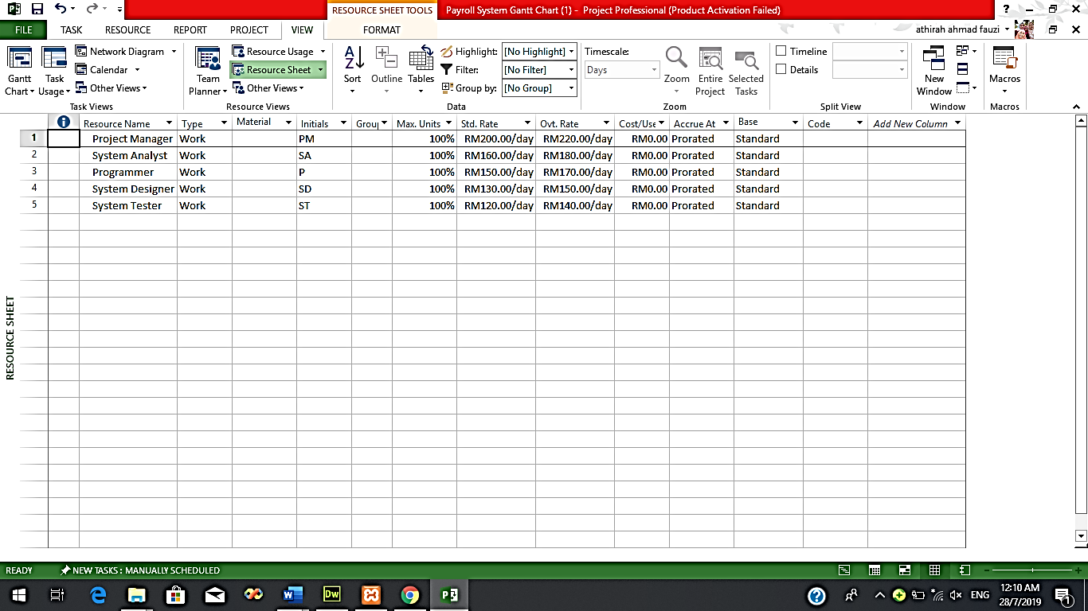**Resources sheet**

**Figure 9**

1. **Gantt Chart by cost**

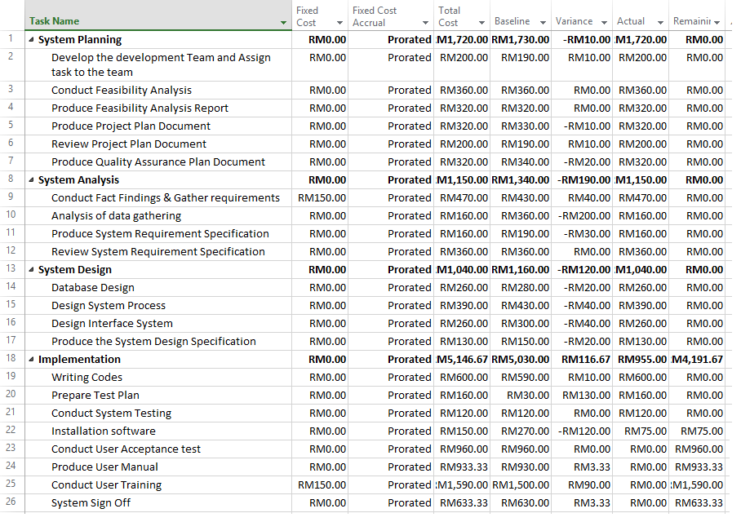

**Figure 10**

1. 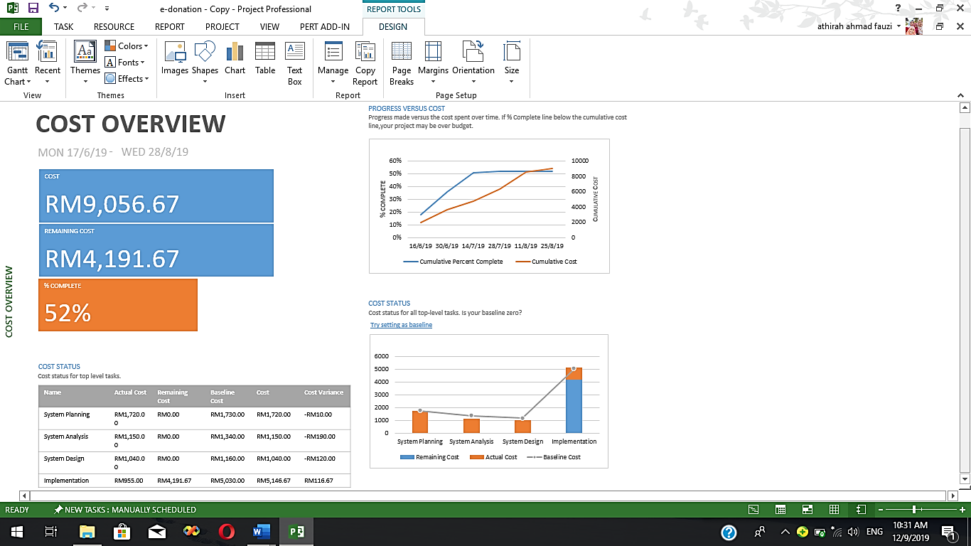**Report Overview cost**

**Figure 11**

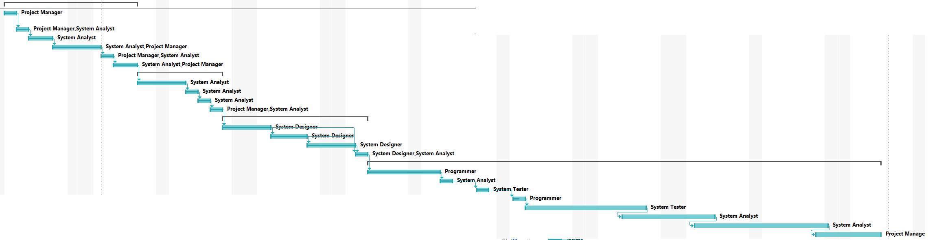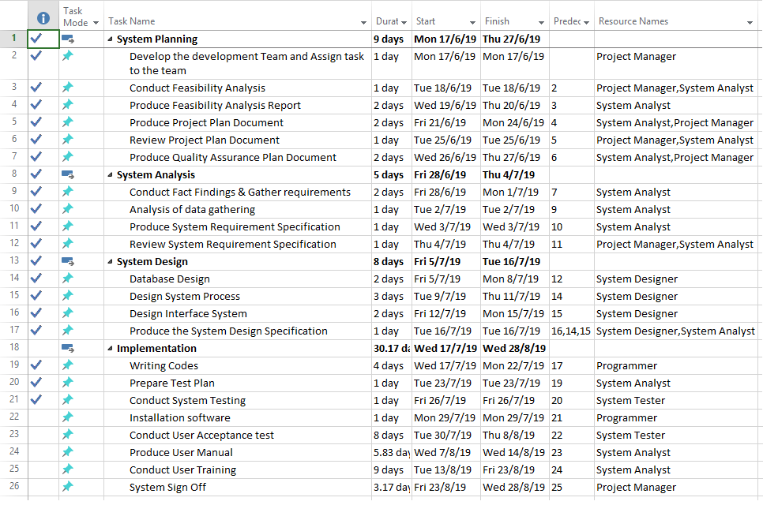**Evaluate whether the Gantt Chart produced meets the deadlines of the project. Explain briefly the activities conducted for each stage. (D2.2)**

**Figure 12**

Based on the Gantt Chart that has been produced for the development of e-Donation Application, there are four stages that has been conducted which is System Planning, System Analysis, System and Implementation. The activities that has been analysed in Gantt Chart for the development of e-Donation Application has been conducted and meet the deadlines of the project.

The first stage is **System Planning**. This stage has been conducted in 9 days which from 17th June 2019 to 27th June 2019. In this stage, there are few task breakdowns that has been conducted. The first task is develop the development team and assign task to the team. This task has been conducted by Project Manager in 1 day which was at 17th June 2019. The next task is conduct feasibility analysis. This task has been conducted in 1 day at 18th June 2019. The other task that has been conducted in this stage is produce feasibility analysis report which was conducted in 2 days from 19th June 2019 until 20th June 2019. Then, in 2 days from 21st June 2019 until 24th June 2019, project plan document has been produced and at 25th June 2019, the project plan has been reviewed by Project Manager. The last task in this stage is produce Quality Assurance Plan Document has been conducted in 2 days from 26th June 2019 until 27th June 2019. In this stage, only Project Manager and System Analyst was involved. All the tasks in this stage has been conducted smoothly and meet the deadlines of the project.

The next stage for the development of e-Donation Application is **System Analysis**. In this stage, there are few tasked that has been conducted and meet the deadlines of the project. This stage has been conducted in 6 days from 28th June 2019 until 4th July 2019. The first task that has been carried out in this stage is conduct fact findings & gather requirements. This activity has been managed in 2 days from 28th June 2019 until 1st July 2019 by System Analyst. The next activity in this stage is analysis of data gathering. This activity has been carried out in 1 days at 2nd July 2019. Then, the system requirement specification for the e-Donation Application has been produced in this stage in 2 days from 3rd July 2019 until 4th July 2019. The last task in this stage is review system requirement specification. The Project Manager and System Analyst has been reviewed the system requirement specification for e-Donation Application in 1 day at 5th July 2019. All the task planned in System Analysis stage has been carried out and meet the deadline of the project.

The third stage for the development of e-Donation Application is **System Design**. In this stage, there are four task breakdown that has been conducted in 8 days from 5th July 2019 until 16th July 2019 and all the planned task was meet the deadline of the project. The first activity is database design. The database has been designed by System Designer in 2 days from 5th July 2019 until 8th July 2019. The next activity in this stage is designing system process. This activity has been carried out in 3 days from 9th July 2019 until 11th July 2019. Then, the System Designer has designed the interface of the system in this stage. System Designer designed the interface in 2 days from 12th July 2019 until 15th July 2019. Then, the last activity that the System Designer has done was producing the System Design Specification (SDS). The SDS was produced in 1 days at 16th July 2019. All the tasks in this stage has been conducted smoothly and meet the deadlines of the project.

The last stage involved in the development of e-Donation Application is **Implementation**. In this stage, it involved few task breakdowns and has been conducted in 8 days from 17th July 2019 until 26th July 2019 which meet the deadline of the project. The first task involved in this stage is writing codes. The programmer has written the code for the system, e-Donation Application in 4 days from 17th July 2019 until 22th July 2019. Then, the test plan has been prepared in 1 day at 23rd July 2019. Then, the testing activity for the system was carried out in 1 day at 26th July 2019. Then, the next activity in this stage is installation software. This activity has been conducted also in 1 day at 29th July 2019. All the task planned in this stage has been carried out smoothly and meet the deadline of the project except for conduct user acceptance test, produce user manual, conduct user training and system sign off. These tasks are not conducted yet and will be conducted as the planned date. This is because the installation of the software is only done 50%.

As conclusion, all the stages that has been planned in Gantt Chart was conducted smoothly and has meet the deadlines of the project.

**Develop an IT project using an appropriate software tool. (Provide hardcopy and softcopy of the IT Project as evidence). Produce test cases to show verification of the project implementation. (P2.2)**

**Hardcopy of the system**

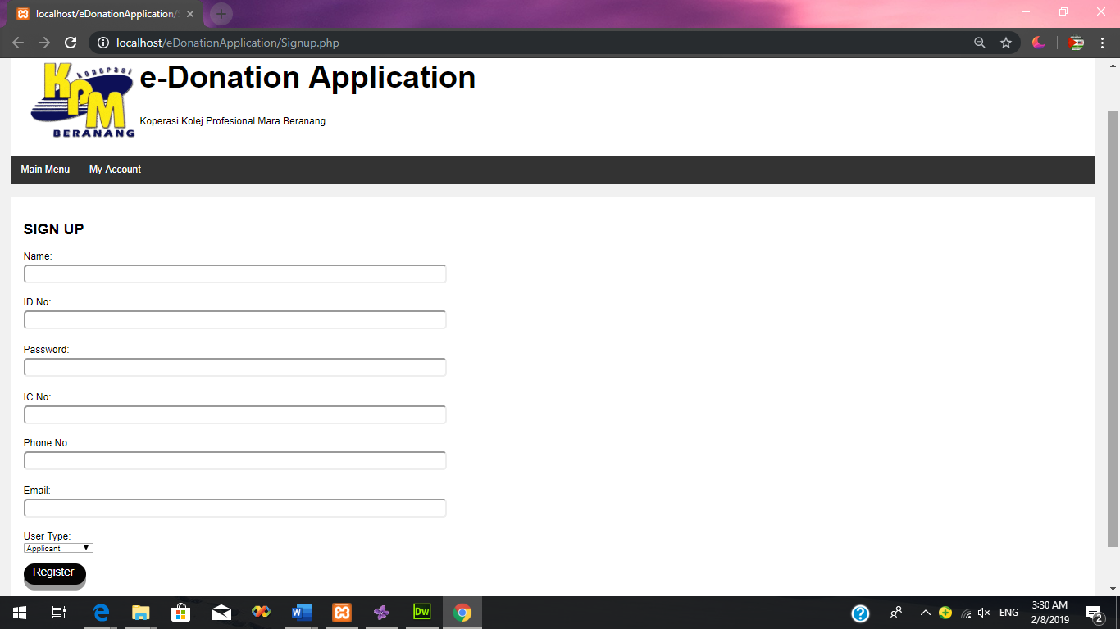**1. Sign Up Form**

**Figure 13**

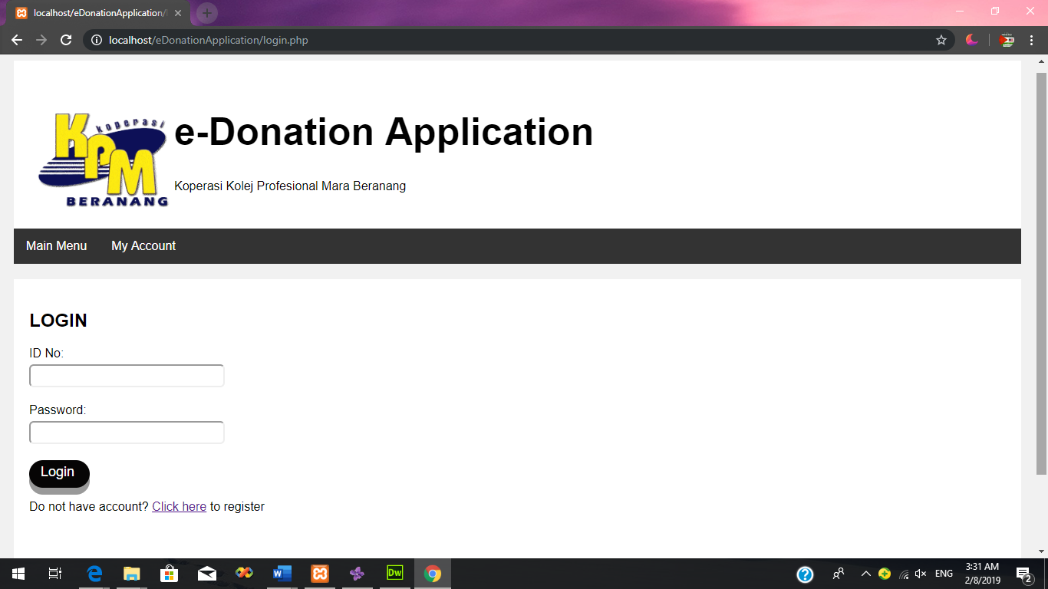**2. Login Form**

**Figure 14**

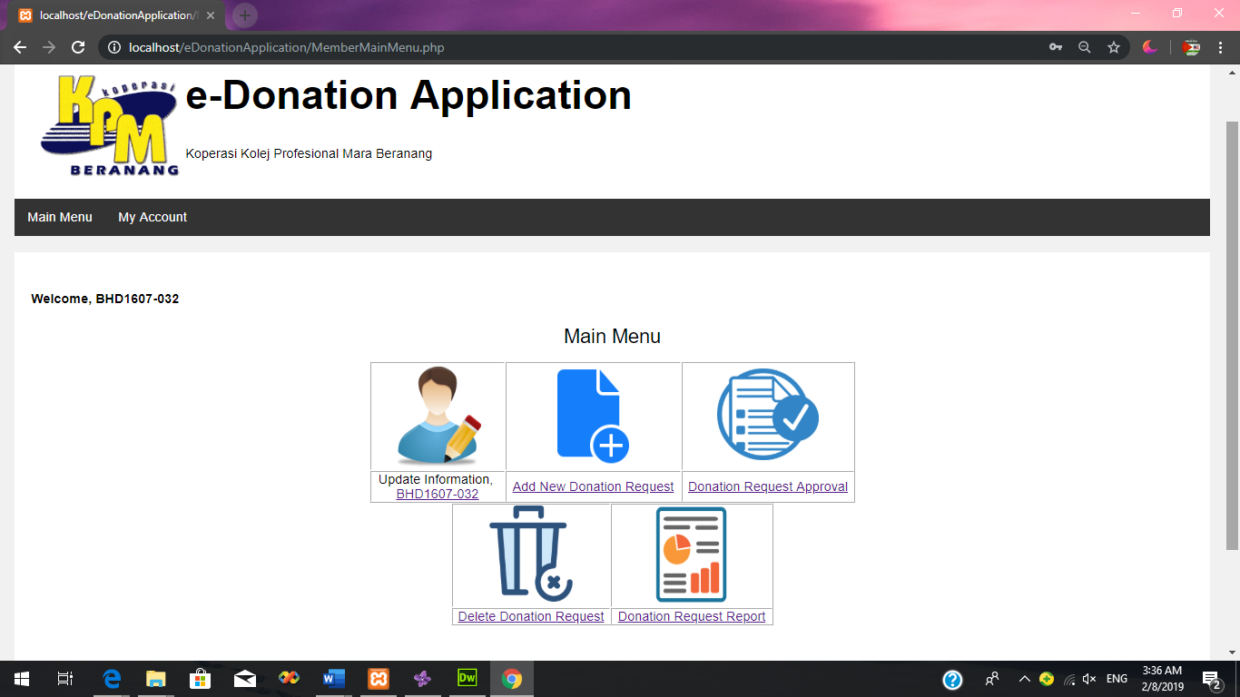**3. Member Main Menu**

**Figure 15**

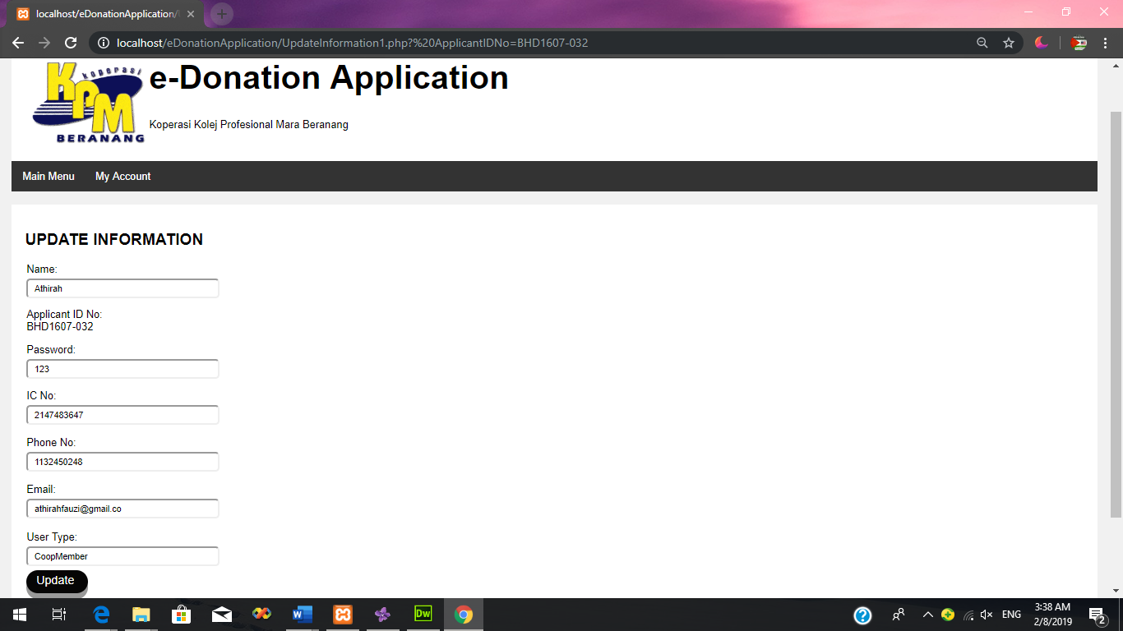**4. Update Information form**

**Figure 16**

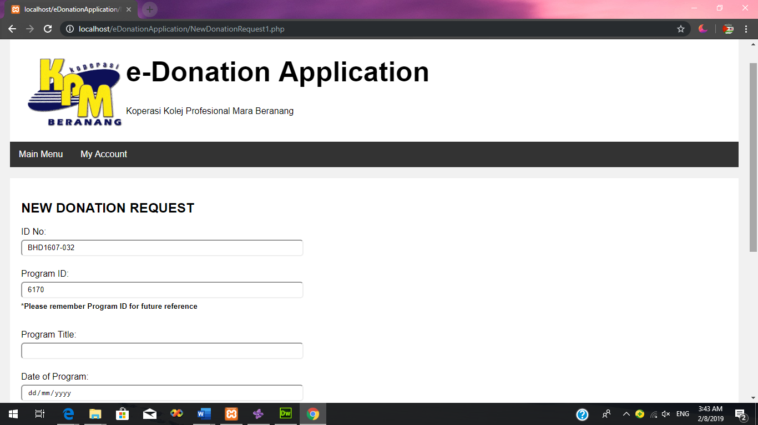**5. New Donation Request Form**

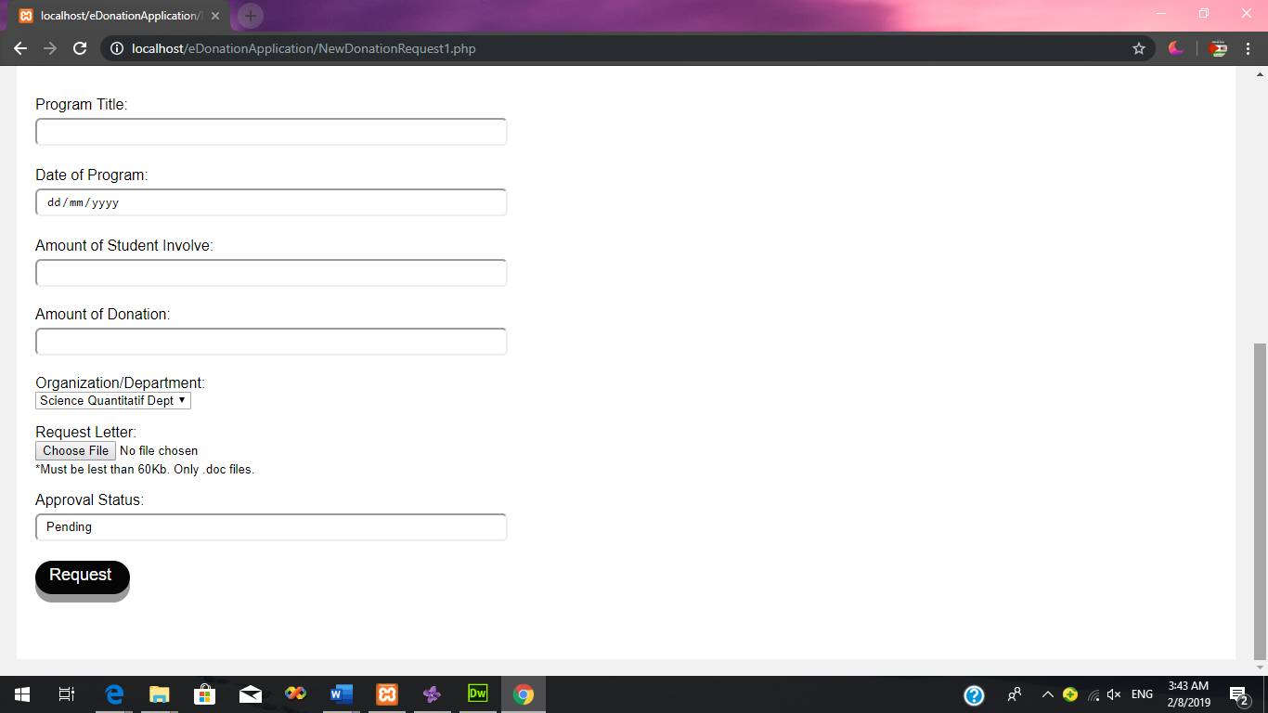

**Figure 17**

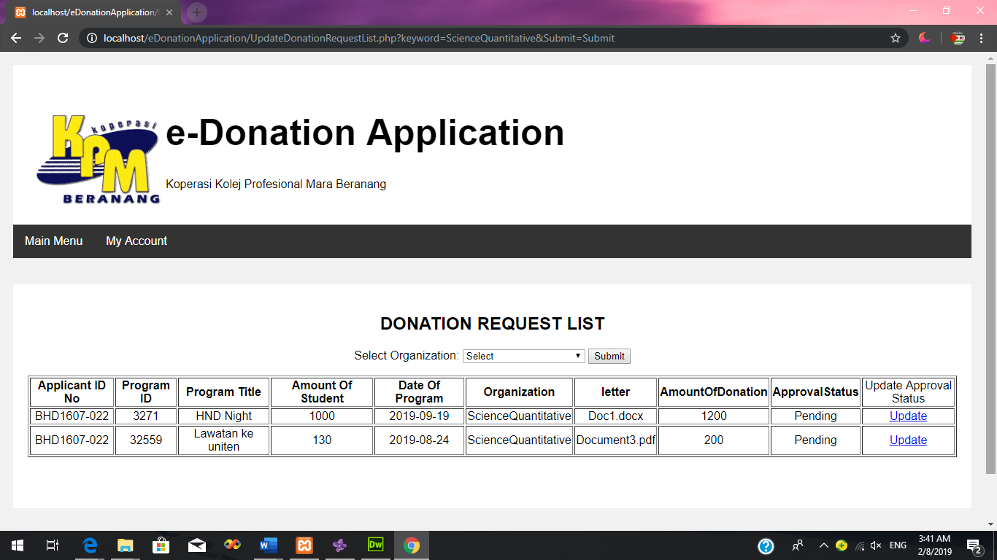**6. Donation Request List**

**Figure 18**

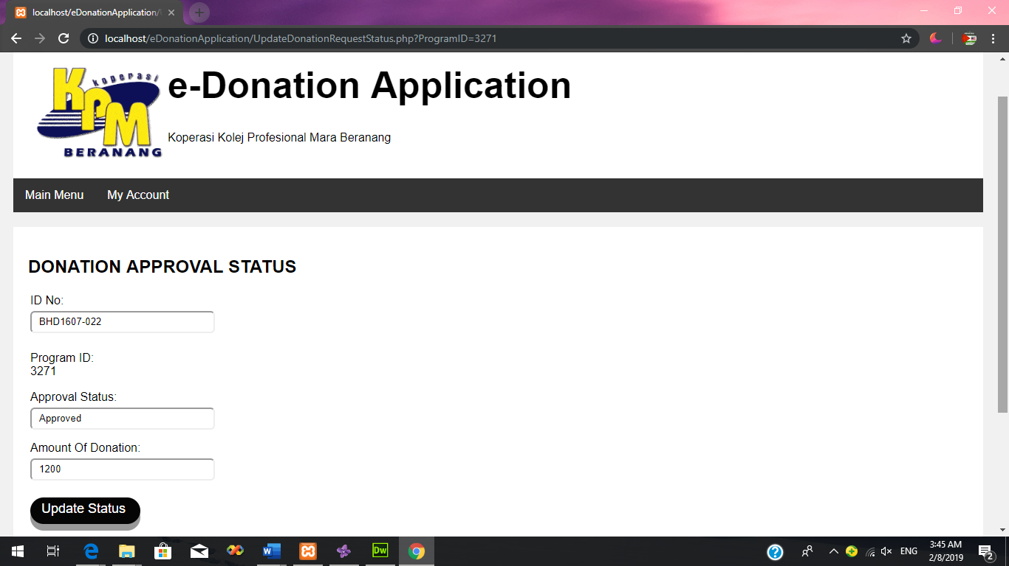**7. Update Donation Approval Status**

**Figure 19**

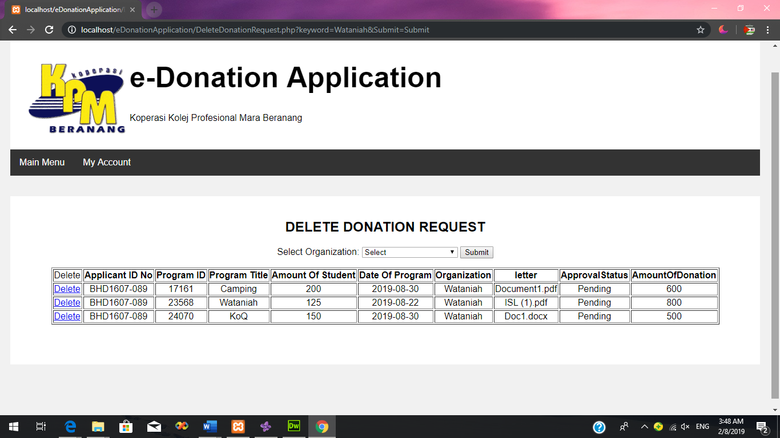**8. Delete Donation Request List**

**Figure 20**

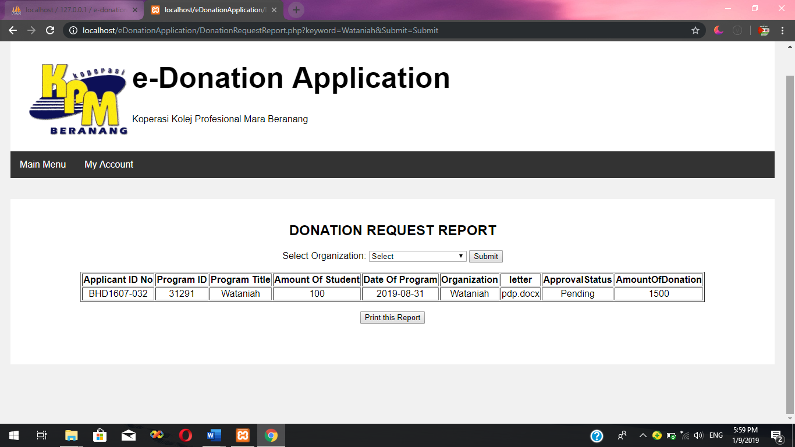**9. Report Donation Request**

**Figure 21**

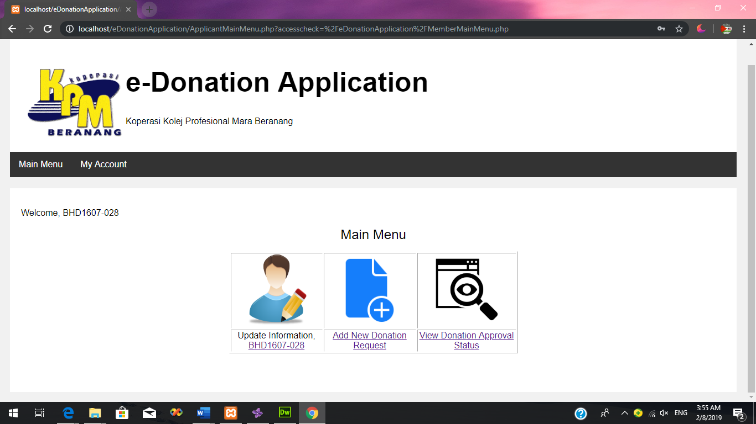**10. Applicant Main Menu**

**Figure 22**

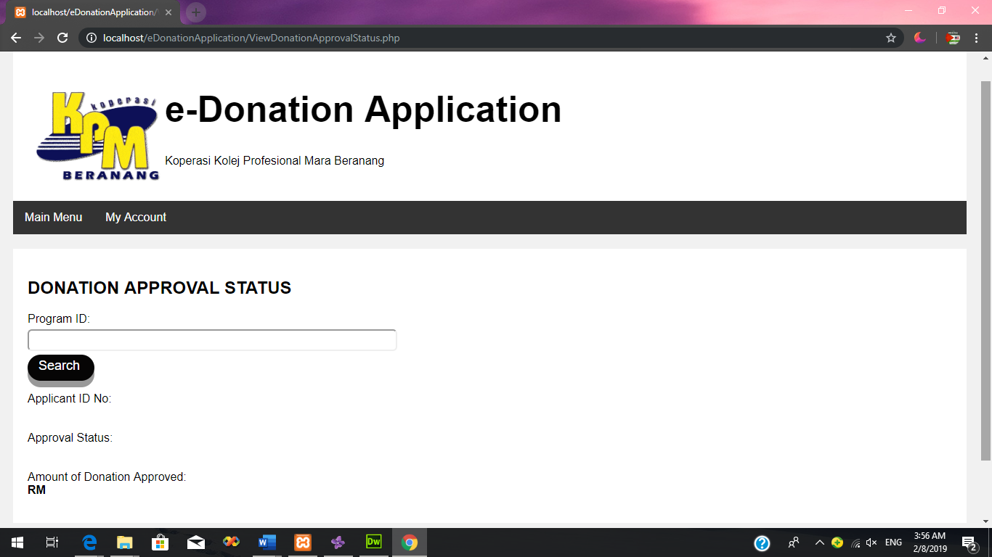**11. View Donation Approval Status**

**Figure 23**

1. **Login page**

**1.1 Member login**

|  |  |  |  |  |  |  |
| --- | --- | --- | --- | --- | --- | --- |
| **Test Case ID** | **Test Case Description** | **Input Data** | **Expected Result** | **Actual Result** | **Pass/Fail** | **Remarks** |
| T1.1 | Enter correct ID Number and Password and click login button | ID No: BHD1607-032  Password:123 | The system will display member main menu | The system displayed member main menu | Pass | None |
| Enter incorrect ID No and Password and click login button | ID No: gdygdh  Password: 741 | The system will display Unsuccessful page. | The system displayed Unsuccessful page | Pass | None |
| T1.2 | Click on Click Here button | - | The system will display Sign Up page | The system displayed Sign Up page | Pass | None |

* 1. **Applicant Login**

|  |  |  |  |  |  |  |
| --- | --- | --- | --- | --- | --- | --- |
| **Test Case ID** | **Test Case Description** | **Input Data** | **Expected Result** | **Actual Result** | **Pass/Fail** | **Remarks** |
| T1.3 | Enter correct ID Number and Password and click login button | ID No: BHD1607-028  Password:123 | The system will display applicant main menu | The system displayed applicant main menu | Pass | None |
| Enter incorrect ID No and Password and click login button | ID No: BHD45678  Password: 741 | The system will display Unsuccessful page. | The system displayed Unsuccessful page | Pass | None |
| T1.4 | Click on Click here button | - | The system will display Sign Up page | The system displayed Sign Up page | Pass | None |

1. **Main Menu Page**

**2.1 Member Main Menu**

|  |  |  |  |  |  |  |
| --- | --- | --- | --- | --- | --- | --- |
| **Test Case ID** | **Test Case Description** | **Input Data** | **Expected Result** | **Actual Result** | **Pass/Fail** | **Remarks** |
| T2.1 | Click on ID No at Update Information | - | The system will display Update Information page. | The system displayed Update Information page. | Pass | None |
| T2.2 | Click on Add New Donation Request button | - | The system will display New Donation Request page | The system displayed New Donation Request page | Pass | None |
| T2.3 | Click on Donation Request List button | - | The system will display Donation Request List page. | The system displayed Donation Approval Status list page. | Pass | None |
| T2.4 | Click on Delete Donation Request button | - | The system will display Delete Donation Request list page. | The system displayed Delete Donation Request list page. | Pass | None |
| T2.5 | Click on Donation Request Report button | - | The system will display Donation Request Report page. | The system displayed Donation Request Report page. | Pass | None |

**2.2 Applicant Main Menu**

|  |  |  |  |  |  |  |
| --- | --- | --- | --- | --- | --- | --- |
| **Test Case ID** | **Test Case Description** | **Input Data** | **Expected Result** | **Actual Result** | **Pass/Fail** | **Remarks** |
| T2.6 | Click on Add New Donation Request button | - | The system will display New Donation Request page | The system displayed New Donation Request page | Pass | None |
| T2.7 | Click on ID No at Update Information | - | The system will display Update Information page. | The system displayed Update Information page. | Pass | None |
| T2.8 | Click on View Donation Approval Status button | - | The system will display Donation Request Status page | The system displayed Donation Request Status page | Pass | None |

1. **Add New Donation Request Page**

**3.1** **Member Add New Donation Request**

|  |  |  |  |  |  |  |
| --- | --- | --- | --- | --- | --- | --- |
| **Test Case ID** | **Test Case Description** | **Input Data** | **Expected Result** | **Actual Result** | **Pass/Fail** | **Remarks** |
| T3.1 | Enter correct information regarding the program information and donation information in the text box and click Request button | Program Title: Moh Gogar  Date of Program: 02/07/2019  Amount of Student Involve: 500  Amount of Donation: 1800  Organization/Department: General Study Dept  Program Letter: Surat.docx | The system will save the information in the database and the Member Main Menu page will be displayed | The system saved the information in the database and the Member Main Menu page is displayed | Pass | None |

**3.2 Applicant Add New Donation Request**

|  |  |  |  |  |  |  |
| --- | --- | --- | --- | --- | --- | --- |
| **Test Case ID** | **Test Case Description** | **Input Data** | **Expected Result** | **Actual Result** | **Pass/Fail** | **Remarks** |
| T3.2 | Enter correct information regarding the program information and donation information in the text box and click Request button | Program Title: Career Talk  Date of Program: 03/07/2019  Amount of Student Involve: 150  Amount of Donation: 700  Organization/Department: Science Quantitative Dept  Request letter: Surat.docx | The system will save the information in the database and the Applicant Main Menu page will be displayed | The system saved the information in the database and the Applicant Main Menu page is displayed | Pass | None |

1. **Donation Request**

**4.1 Donation Request List Page**

|  |  |  |  |  |  |  |
| --- | --- | --- | --- | --- | --- | --- |
| **Test Case ID** | **Test Case Description** | **Input Data** | **Expected Result** | **Actual Result** | **Pass/Fail** | **Remarks** |
| T4.1 | Select Organization  /Department and click on submit button | Select Organization/Department: General Study Dept | The system will display list of donation request by the General Study Dept. | The system displayed report of donation request by the General Study Dept. | Pass | None |
| T4.2 | Click on the Update Status button | - | The system will display Donation Approval Status page including the Donation Information of the applicant | The system displayed Donation Approval Status including the Donation Information of the applicant | Pass | None |

* 1. **Donation Approval Status Page**

|  |  |  |  |  |  |  |
| --- | --- | --- | --- | --- | --- | --- |
| **Test Case ID** | **Test Case Description** | **Input Data** | **Expected Result** | **Actual Result** | **Pass/Fail** | **Remarks** |
| T4.3 | Update approval Status and Amount of Donation and click Update Status button | Approval Status: Approved  Amount of Donation Approved: 1200 | The system will update the Approval Status and Amount of Donation in database and will display Donation Request List page | The system updated the Approval Status and Amount of Donation in database and displayed Donation Request List page | Pass | None |

1. **Delete Donation Request page**

|  |  |  |  |  |  |  |
| --- | --- | --- | --- | --- | --- | --- |
| **Test Case ID** | **Test Case Description** | **Input Data** | **Expected Result** | **Actual Result** | **Pass/Fail** | **Remarks** |
| T5.1 | Select Organization  /Department and click on submit button | Select Organization/Department: General Study Dept | The system will display rlist of donation request by the General Study Dept. | The system displayed report of donation request by the General Study Dept. | Pass | None |
| T5.2 | Click on the Delete button | - | The system will delete the Donation Information of the selected row | The system deleted the Donation Information of the selected row | Pass | None |

1. **Donation Request Report page**

|  |  |  |  |  |  |  |
| --- | --- | --- | --- | --- | --- | --- |
| **Test Case ID** | **Test Case Description** | **Input Data** | **Expected Result** | **Actual Result** | **Pass/Fail** | **Remarks** |
| T6.1 | Select Organization  /Department and click on submit button | Select Organization/Department: General Study Dept | The system will display report of donation request by the General Study Dept. | The system displayed report of donation request by the General Study Dept. | Pass | None |

1. **View Donation Approval Status page**

|  |  |  |  |  |  |  |
| --- | --- | --- | --- | --- | --- | --- |
| **Test Case ID** | **Test Case Description** | **Input Data** | **Expected Result** | **Actual Result** | **Pass/Fail** | **Remarks** |
| T7.1 | Enter correct Program ID and click Search button | Program ID: 12464 | The system will display Donation Information of the Program ID. | The system displayed Donation Information of the Program ID. | Pass | None |
| Enter incorrect Program ID and click Search button | Program ID: H | The system will not display the Donation Information | The system not displayed the Donation Information | Pass | None |

1. **Update Information**

**8.1 Member Update Information**

|  |  |  |  |  |  |  |
| --- | --- | --- | --- | --- | --- | --- |
| **Test Case ID** | **Test Case Description** | **Input Data** | **Expected Result** | **Actual Result** | **Pass/Fail** | **Remarks** |
| T8.1 | User update information and click Update Status button | Name: Athirah  ID No: BHD1607-032  Password: 123  IC No: 981107055555  Phone No:017998212  Email: [fatinhanisah@gmail.com](mailto:fatinhanisah@gmail.com)  User Type: CoopMember | The system will update the information in database and will display pop-up message “Your Information has been update.” | The system updated the information in database and displayed pop-up message “Your Information has been update.” | Pass | None |

**8.2 Applicant Update Information**

|  |  |  |  |  |  |  |
| --- | --- | --- | --- | --- | --- | --- |
| **Test Case ID** | **Test Case Description** | **Input Data** | **Expected Result** | **Actual Result** | **Pass/Fail** | **Remarks** |
| T8.1 | User update information and click Update Status button | Name: Fatin Hanisah  ID No: BHD1607-032  Password: 123  IC No: 981107055555  Phone No:017998212  Email: [fatinhanisah@gmail.com](mailto:fatinhanisah@gmail.com)  User Type: Applicant | The system will update the information in database and will display pop-up message “Your Information has been update.” | The system updated the information in database and displayed pop-up message “Your Information has been update.” | Pass | None |

1. **Sign Up page**

|  |  |  |  |  |  |  |
| --- | --- | --- | --- | --- | --- | --- |
| **Test Case ID** | **Test Case Description** | **Input Data** | **Expected Result** | **Actual Result** | **Pass/Fail** | **Remarks** |
| T8.1 | Enter correct information and click Register button | Name: Fatin Hanisah  ID No: BHD1607-002  Password: 123  IC No: 981107055555  Phone No:017998212  Email: [fatinhanisah@gmail.com](mailto:fatinhanisah@gmail.com)  Usertype: applicant | The system will save the information in database and display Successful message page. | The system saved the information in database and displayed Successful message page. | Pass | None |

**Analyse and explain the verification outcomes based on the test cases. (P2.3)**

1. **Login page**
   1. **Member Login**

**Test case T1.1: Member enter ID No and Password**

This test case was conducted to determine whether the system is able to display member main menu after enter the ID No and Password into the text box provided. When user enter correct data which ID No: BHD1607-032 and Password:123 and click the Login button, the system was successfully displayed member main menu. While for incorrect data, when user enter wrong ID No and Password such as ID No: gdygdh and Password: 741, the system successfully displayed Unsuccessful message page. This test case is pass because the actual result for both correct and incorrect data input is same as the expected result.

**Test case T1.2: Click on Click here button**

This test case was conducted to make sure that the button is functioning and open correct page. When user click on the Click Here button in login page, the system is successfully displayed Sign Up page. This test case is pass because the actual result is same as the expected result.

* 1. **Applicant Login**

**Test case T1.3: Applicant enter ID No and Password**

This test case was conducted to determine whether the system is able to display applicant main menu after enter the ID No and Password into the text box provided. When user enter correct data which ID No: BHD1607-028 and Password:123 and click the Login button, the system was successfully displayed applicant main menu. While for incorrect data, when user enter wrong ID No and Password such as ID No: BHD45678 and Password: 741, the system successfully displayed Unsuccessful message page. This test case is pass because the actual result for both correct and incorrect data input is same as the expected result.

**Test case T1.4: Click on Click Here button**

This test case was conducted to make sure that the button is functioning and open correct page. When user click on the Click Here button in login page, the system is successfully displayed Sign Up page. This test case is pass because the actual result is same as the expected result.

1. **Main Menu Page**

**2.1 Member Main Menu**

**Test case T2.1: Click on ID No at Update Information**

This test case was conducted to make sure that the button is functioning and open correct page. When user click on ID No at Update Information in member main menu page, the system is successfully displayed Update Information page. This test case is pass because the actual result is same as the expected result.

**Test case T2.2: Click on** **Add New Donation Request**

This test case was conducted to make sure that the button is functioning and open correct page. When user click on Add New Donation Request button in member main menu page, the system is successfully displayed New Donation Request page. This test case is pass because the actual result is same as the expected result.

**Test case T2.3: Click on Donation Approval Status button**

This test case was conducted to make sure that the button is functioning and open correct page. When user click on Donation Request List button in member main menu page, the system is successfully displayed Donation Request List Page. This test case is pass because the actual result is same as the expected result.

**Test case T2.4: Click on Delete Donation Request button**

This test case was conducted to make sure that the button is functioning and open correct page. When user click on Delete Donation Request button in member main menu page, the system is successfully displayed Delete Donation Request page. This test case is pass because the actual result is same as the expected result.

**Test case T2.5: Click on Donation Request Report button**

This test case was conducted to make sure that the button is functioning and open correct page. When user click on Donation Request Report button in member main menu page, the system is successfully displayed Donation Request Report page. This test case is pass because the actual result is same as the expected result.

**2.2 Applicant Main menu**

**Test case T2.6: Click on Add New Donation Request**

This test case was conducted to make sure that the button is functioning and open correct page. When user click on Add New Donation Request button in applicant main menu page, the system is successfully displayed New Donation Request page. This test case is pass because the actual result is same as the expected result.

**Test case T2.7: Click on ID No at Update Applicant Information**

This test case was conducted to make sure that the button is functioning and open correct page. When user click on ID No at Update Applicant Information in applicant main menu page, the system is successfully displayed Update Information page. This test case is pass because the actual result is same as the expected result.

**Test case T2.8: Click on View Donation Approval Status button**

This test case was conducted to make sure that the button is functioning and open correct page. When user click on View Donation Approval Status button in applicant main menu page, the system is successfully displayed View Donation Approval Status page. This test case is pass because the actual result is same as the expected result.

1. **Add New Donation Request Page**

**3.1 Member Add New Donation Request**

**Test case T3.1: Add New Donation Request**

This test case is conducted to determine whether the system is able to make request for the donation. When member enter correct data regarding the program information and donation information such as Program Title: Moh Gogar, Date of Program: 02/07/2019, Amount of Student Involve: 500, Amount of Donation: 1800, Organization/Department: General Study Dept and Program Letter: Surat.docx., the data is saved in the database and the system successfully displayed member main menu page after click on the Request button. Thus, this test case for correct and incorrect data is pass because the actual result is same as the expected result.

**3.2 Applicant Add New Donation Request**

**Test case T3.2: Add New Donation Request**

This test case is conducted to determine whether the system is able to make request for the donation. When applicant enter correct data regarding the program information and donation information such as Program Title: Career Talk, Date of Program: 03/07/2019, Amount of Student Involve: 150, Amount of Donation: 700, Organization/Department: Science Quantitative Dept and Program Letter: Surat.docx., the data is saved in the database and the system successfully displayed applicant main menu page after click on the Request button. Thus, this test case for correct and incorrect data is pass because the actual result is same as the expected result.

1. **Donation Request List**

**4.1 Donation Request List page**

**Test Case T4.1: Select Organization/Department**

This test case was conducted to determine whether the system is able to display the list of donation request by selected organization or department. When member select the Organization/Department such as General Study Dept and clicked on the Submit button, the system automatically displayed the report of donation request by the General Study Dept. So, this test case is pass because the actual result is same as the expected result.

**Test Case T4.2: Click on the Update Status button**

This test case was conducted to make sure that the button is functioning and open correct page. When user click on Update Status button in Donation Request List page, the system is successfully displayed Donation Approval Status page which including the Donation Information of the applicant. This test case is pass because the actual result is same as the expected result.

**4.2 Donation Approval Status Page**

**Test Case T4.3: Update approval Status and Amount of Donation and click Update Status button**

This test case was conducted to determine whether the donation approval status and amount of donation can be updated. When member updated and entered approval status and amount of donation approved and then click on the Update Status button, the system successfully updated the information to the database and displayed the Donation Request List Page. This test case is pass because the actual result is same as the expected result.

1. **Delete Donation Request**

**Test Case T5.1: Select Organization/Department**

This test case was conducted to determine whether the system is able to display the list of donation request by selected organization or department. When member select the Organization/Department such as General Study Dept and clicked on the Submit button, the system automatically displayed the report of donation request by the General Study Dept. So, this test case is pass because the actual result is same as the expected result.

**Test Case T5.2: Click on the Delete button**

This test case was conducted to determine whether the system is able to delete the donation information of the selected row. This page displayed in list all the Donation Information. When member click on the delete button provided in this page, the system automatically deleted the information of the selected row. So, this test case is pass because the actual result is same as the expected result.

1. **Donation Request Report**

**Test Case T6.1: Select Organization/Department**

This test case was conducted to determine whether the system is able to display the report by selected organization or department. When member select the Organization/Department such as General Study Dept and clicked on the Submit button, the system automatically displayed the report of donation request by the General Study Dept. So, this test case is pass because the actual result is same as the expected result.

1. **View Donation Approval Status**

**Test Case T7.1: Enter Program ID and click Search button**

This test case was conducted to determine whether the system is able to displayed the correct Donation Information or not. When applicant enter correct Program ID such as 12464 and click search button, the system successfully displayed correct Donation Information of the Program ID. But when the applicant entered incorrect data, the system not displayed the Donation Information. So, this test case is pass because the actual result for both correct and incorrect data is same as the expected result.

1. **Update Information**

**Test case T8.1: Member Update Information**

This test case was conducted to determine whether the member information can be updated. When member entered and updated correct data such as Name: Athirah, ID No: BHD1607-032, Password: 123, IC No: 981107055555, Phone No:017998212, Email: [fatinhanisah@gmail.com](mailto:fatinhanisah@gmail.com) and User Type: CoopMember and then click on the Update button, the system successfully updated the information to the database and displayed the pop-up message “Your Information has been updated”. This test case is pass because the actual result is same as the expected result.

**Test case T8.2: Member Update Information**

This test case was conducted to determine whether the applicant information can be updated. When member entered and updated correct data such as Name: Fatin Hanisah, ID No: BHD1607-002, Password: 123, IC No: 981107055555, Phone No:017998212, Email: [fatinhanisah@gmail.com](mailto:fatinhanisah@gmail.com) and User Type: Applicant and then click on the Update button, the system successfully updated the information to the database and displayed the pop-up message “Your Information has been updated”. This test case is pass because the actual result is same as the expected result.

1. **Sign Up page**

**Test Case T9.1: Enter information and click Register button**

This test case is conducted to determine whether the system is able to save the information of the user or not. When user enter correct data such as Name: Fatin Hanisah, ID No: BHD1607-002, Password: 123, IC No: 981107055555, Phone No:017998212, Email: [fatinhanisah@gmail.com](mailto:fatinhanisah@gmail.com) and User Type: applicant and then click on the register button, the system successfully save the information of the user and display the successful message page. Thus, this test case is pass because the actual result is same as the expected result.

**Conduct the overall project verification outcome based on any 3 of quality characteristics in ISO/IEC 25010 standard. (D1.4)**

Based on ISO/IEC 25010 standard, there are 3 of quality characteristic that has been analysed for e-Donation Application for project verification purposed. ISO/IEC 25010 standard is referred to the quality model frameworks that describe code quality characteristic and the decomposition. Quality model is the foundation of a product quality evaluation system. When assessing the characteristic of a software product, the quality model determines which quality features will be taken into consideration. The quality of a system is the degree to which the system meets its multiple stakeholders ' stated and implied requirements and therefore offers value. The stakeholders’ need including functionality, performance, security, maintainability, usability, reliability and so on are precisely what is depicted in the quality model that is categorizes the value of the item into characteristic and sub-characteristics. (Iso25000.com, n.d.)

The first identified quality characteristic for project verification is **security**. Security is a degree in which a system protects the information and data for a particular person. The person will have the degree of data access to their types and level of authorization. The sub-characteristics in security that has been analysed for e-Donation Application is **confidentiality**. Confidentiality is the degree to which the system assures that the data are accessible only to those authorized to have the access (Iso25000.com, n.d.). Based on the developed system, e-Donation Application meet the sub-characteristic on project verification, confidentiality. E-Donation Application has the degree in which the system only can be access by the authorized user which is Member of Koperasi KPM Beranang and Applicant. This degree of confidentiality is to ensure that all the data will be protect and cannot be access by unauthorized user. E—Donation Application has login form which user must enter their ID No and password. Below is the figure 24, the login form of e-Donation Application that has been developed. While figure 25 shows its server behaviour from the software development tools, Adobe Dreamweaver which has been set up to make the login user functionality in e-Donation Application.

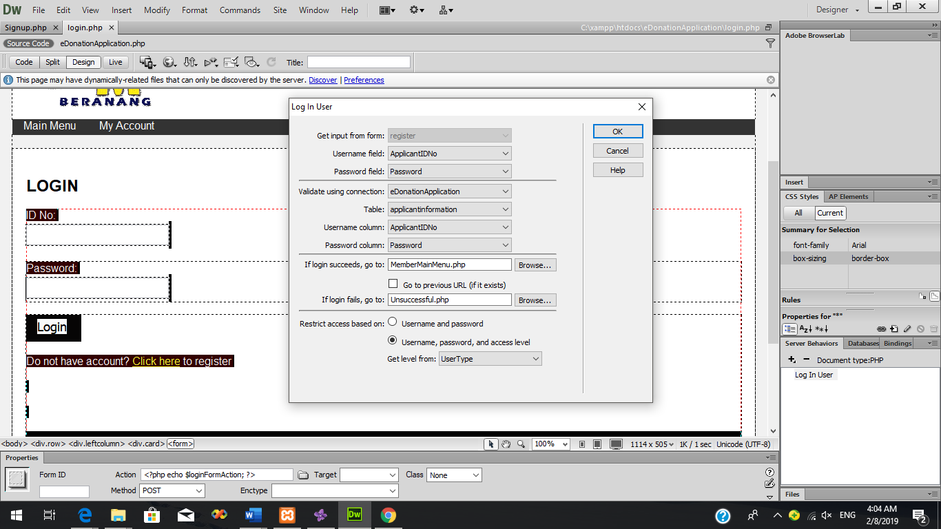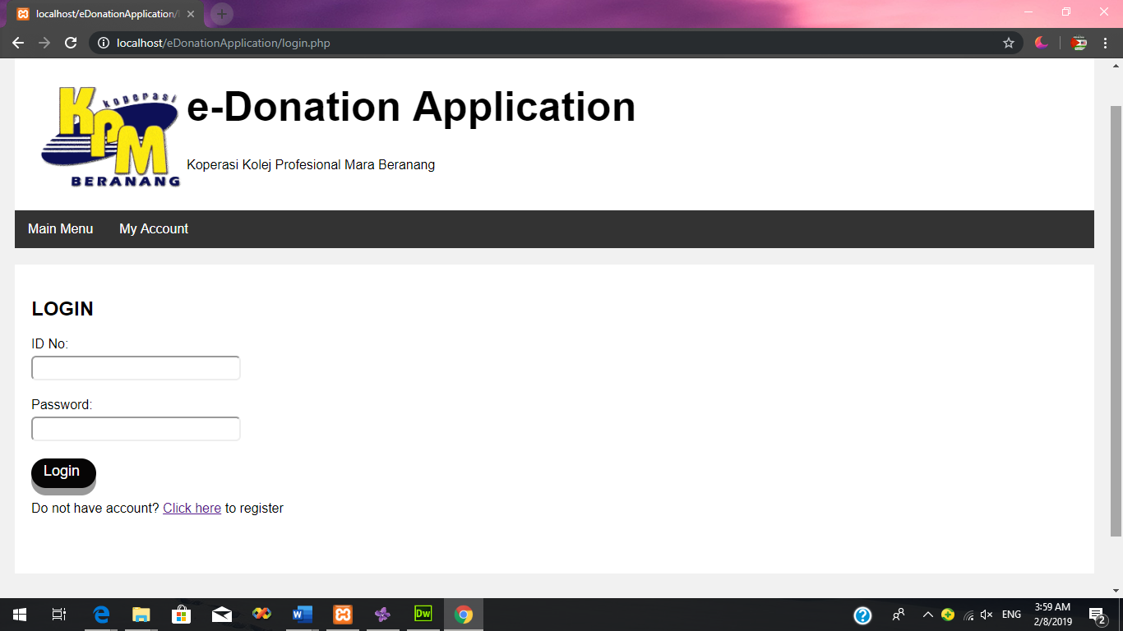**Figure 24: Login Form**

**Figure 25: Login Server Behaviour**

The other quality characteristic in ISO/IEC 25010 standard that met in e-Donation Application is **functional suitability**. Functional suitability is referred to the degree in which the system that provides function that meet the analysed and implied needs when used under specified conditions. One of the functional suitability sub-characteristic is **functional completeness**. Functional completeness is the degree in which the set of function that covers all the specified tasks and user objective (Iso25000.com, n.d.). e-Donation Application met all the specified task and objectives needed by the user. One of the objectives of the system is the system can keep track the total amount of donation that has been applied by the particular Organization/Department.

Based on the figure 26 and 27, the system has been implemented with the report which users can select the particular organization or department and the report will display the program information, donation information and the total amount of donation that has been applied by the organization. The other objectives for the system is the system can be managed by all the members of Koperasi KPM Beranang. Based on figure 28 and 29, the system has been implemented with the login function which member of Koperasi KPM Beranang can log into the system and the main menu for them will be displayed. From the main menu, the user can select the buttons to manage the donation information and program information. While the last objective is system can be used by the applicant to apply for the donation. Based on the figure 30, e-Donation Application has been implemented with the form of donation request which user can apply for donation 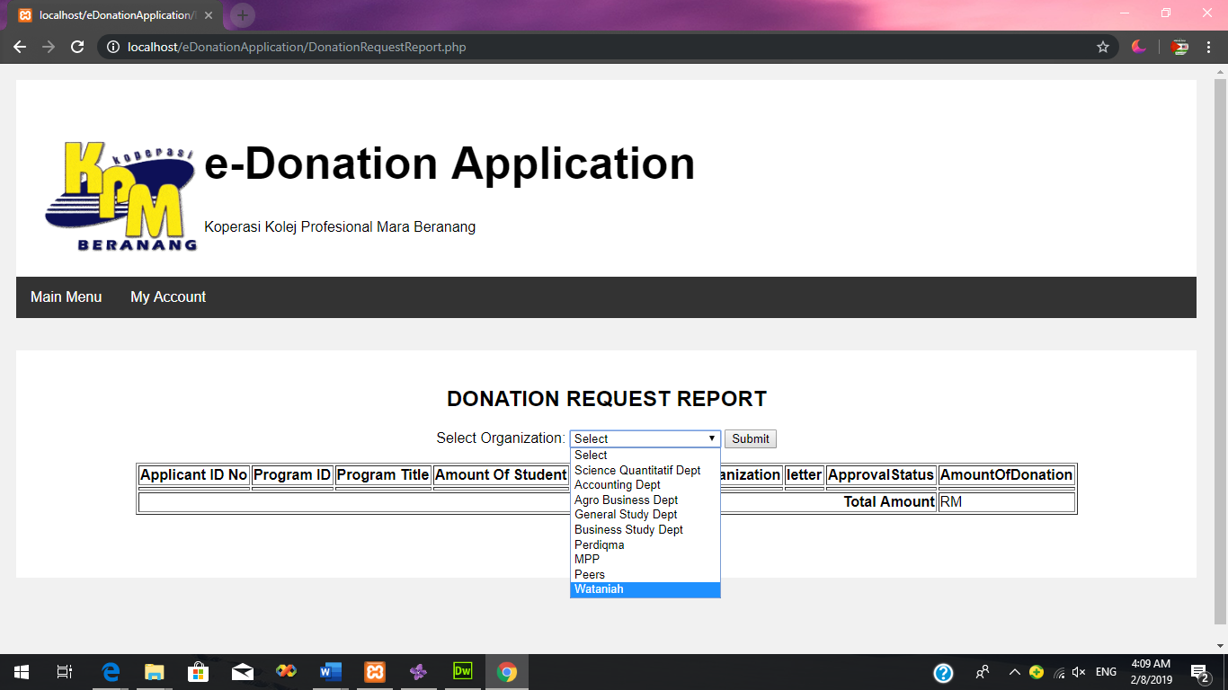through the system.

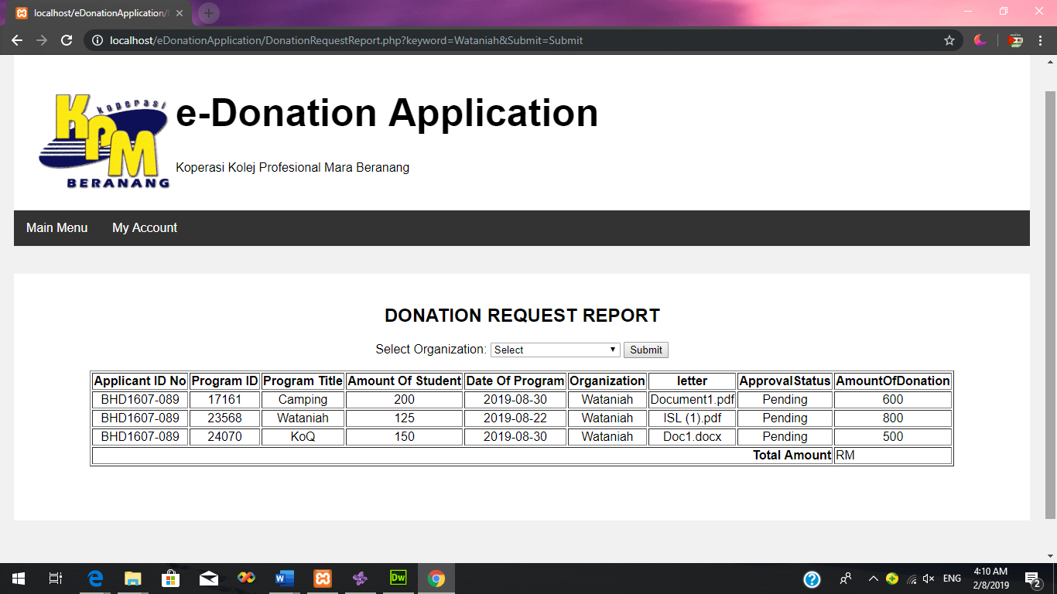**Figure 26: Donation Request Report**

**Figure 27**

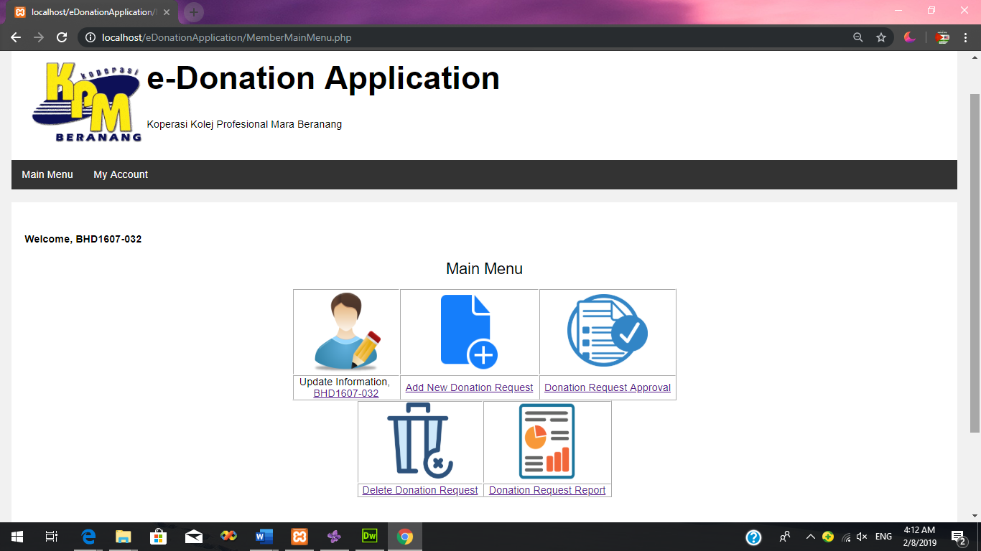**Figure 28: Login Form**

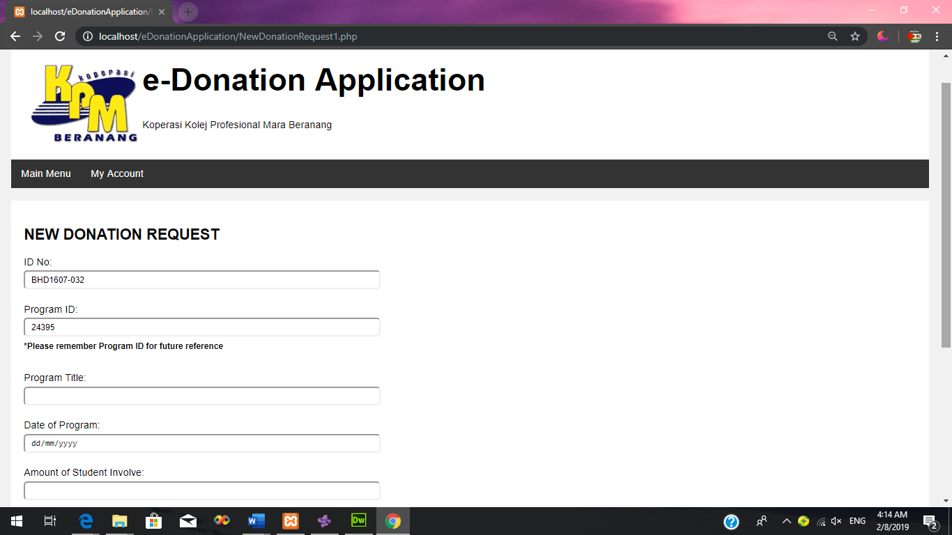**Figure 29: Member Main Menu**

**Figure 30: Donation Request Form**

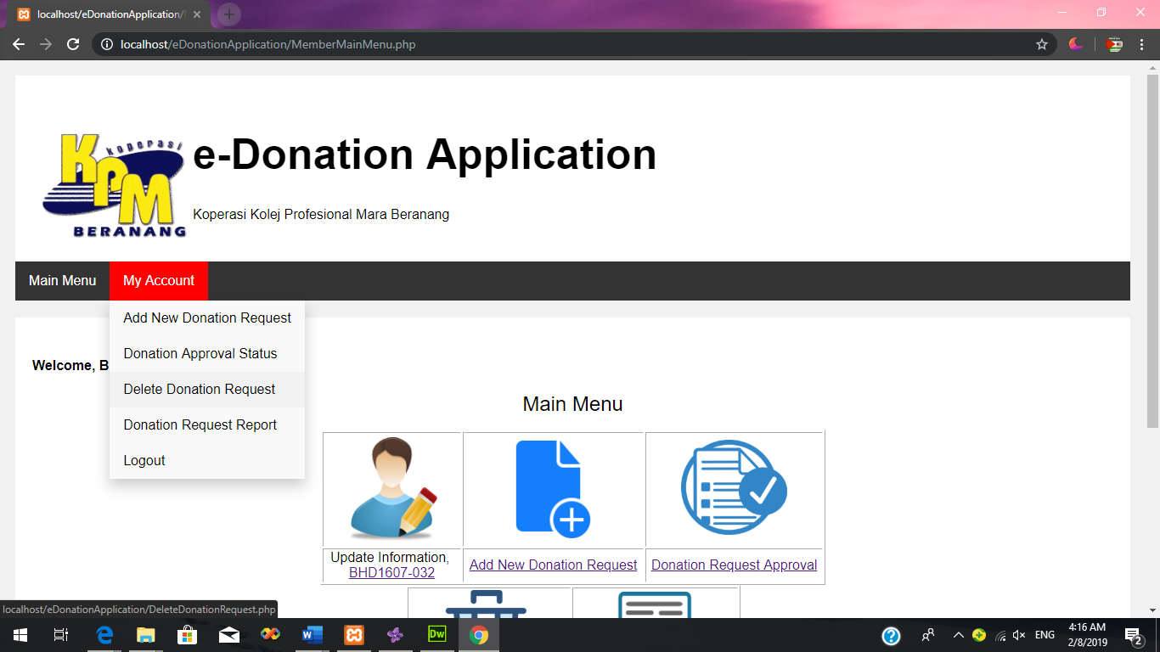The other quality characteristic in ISO/IEC 25010 standard that had been met in e-Donation Application is **usability**. Usability is the degree to which specified users can use the system to achieve the defined objective with efficiency, effectiveness and fulfillment. One of the sub characteristics that has been used for e-Donation Application is **user interface aesthetics**. User interface aesthetics is a degree to which a user interface allows the user to interact pleasingly and satisfyingly. E-Donation Application has a user interface that is very pleasing and satisfying interaction for user. E-Donation Application has very easy and simple interface which can be understood for user to use. Based on the figure 31, E-Donation Application has the navigation bar on each of the pages. Since there are two users for the system, there are two different navigation bars for each of the users. From the navigation bar the user can select which page they want to display. The user can also easily logout from the account by click the button on the navigation bar. Based on the figure 29, for every user also, there are simple main menu page which display the menu where user can click on the image or word in order to display the particular page and each of the user has different main menu page. The system also has been implemented and use simple language which can be understood by all users. The system also has used simple and pleasant layout. (Iso25000.com, n.d.)

**Figure 31: Navigation Bar**